|  |  |
| --- | --- |
| logo ngan.png | MINISTRY OF EDUCATION AND TRAINING |

|  |
| --- |
| **FPT UNIVERSITY** |
| Capstone Project Document |
| Build a Web Application  for Multi-Hotels Booking |
|  |
| |  |  | | --- | --- | | **Group 2** | | | **Group Members** | Nguyễn Phú An – Team Member – 60519  Bùi Minh Đức – Team Member – 60324  Nguyễn Hiếu Triệu Vỹ – Team Leader – SE60793 | | **Supervisor** | Lâm Hữu Khánh Phương | | **Ext Supervisor** | N/A | | **Capstone Project Code** | MHB | |
| Hồ Chí Minh City, December 2013 - |

|  |
| --- |
| *This page is intentionally left blank* |

*Acknowledgement*

After more than three months of intensive researching, working, and having fun, we have finally reached the fundamental objectives of the project *Multi-Hotel Booking*. Apart from our own efforts, the completion of this project depends largely on the encouragement and guidelines of many others. We would like to dedicate this page to expressing our gratitude to the people who have been instrumental in our project.

Firstly and most importantly, we would like to show our greatest respect to Mr. Lâm Hữu Khánh Phương, our supervisor, whose tremendous support and surprising yet innovative ideas contributed a great deal to the completion of our project. Without his encouragement and guidance, this project would probably not have materialized. More than that, we really appreciate the fact that he put us under no pressure whatsoever and always let us having fun while we were working on this project.

Secondly, we would like to thank our fellow men in Group 11, who were also working on a similar project. We will never forget the moments when we were so drawn into arguments that led to nowhere that we even thought we would ended up failing to finish our projects. It was an extraordinarily interesting experience having worked together.

Finally, we would like to express our deepest gratitude to our parents and our lecturers for always being there for us. We appreciate that they did a lot to gear us up for all the things we might encounter in our lives. We would not be who we are today if it weren’t for them.

Group 2  
*Nguyễn Phú An,  
Bùi Minh Đức,  
Nguyễn Hiếu Triệu Vỹ*

*This page is intentionally left blank*

# Table of figures

Figure 1. Model-View-Controller Architecture 6

Figure 2. Home page 41

Figure 3. Search Hotel page 42

Figure 4. Hotel Details page 43

Figure 5. Booking Details page 44

Figure 6. Dashboard page 45

Figure 7. Approve Booking page 47

Diagram 1. Component Diagram 7

Diagram 2. State machine diagram: Booking status transition 28

Diagram 3. State machine diagram: Refund request status transition 28

Diagram 4. Sequence diagram: Search Hotels 29

Diagram 5. Sequence diagram: Add rooms to booking list 30

Diagram 6. Sequence diagram: Book rooms and pay 31

Diagram 7. Sequence diagram: Request a refund 32

Diagram 8. Sequence diagram: Create a hotel 33

Diagram 9. Sequence diagram: Edit a hotel 34

Diagram 10. Sequence diagram: Add a price 35

Diagram 11. Sequence diagram: Approve a booking 36

Diagram 12. Sequence diagram: Approve a refund request 37

Diagram 13. Sequence diagram: Get hotel information from BMT 38

Diagram 14. Sequence diagram: Get prices from BMT 39

Diagram 15. Sequence diagram: Install Facebook tab 40

Diagram 16. Logical database design 49

Diagram 17. Physical database design 56

# Software Design Description (SDD)



## Design Overview

The SDD describes the system architectural design and the detailed designs, including the user interfaces, of the system.

The components should communicate through interfaces. The detailed implementation of each component should be transparent to other components. The passive MVC III pattern is the preferable architecture for the website.

The detailed designs of the system should adopt the basic principles of software design, including “high cohesion, low coupling” and “open to extension, closed to modification” principles.

Each of the following sections is summarized below:

* Section 4.2: Gives a specification of the system architecture design, describing the overall architecture of the system and subsystems.
* Section 4.3: Specifies all the components that should be included in the system, and the communications between them.
* Section 4.4: Describes the class and package diagrams, as well as their descriptions in details, to provide a static view of the system.
* Section 4.4: Describes the sequence diagrams for the use cases specified in the SRS, to provide a dynamic view of the system.
* Section 4.5: Describes the user interfaces, to specify what will be seen by the users of the system.
* Section 4.5: Describes the Database Design, including the relations and the relationships between them.

## System Architectural Design

The MVC III (Model – View – Controller) pattern is used as the overall system architecture, because it specifies a clear distinction between the responsibilities of the components and is appropriate for developing web applications.

3. Exchange data

4. Results

**CONTROLLER**

* Intercepts user input;
* Coordinates the view and model;
* Handles communication between the model and data layer.

**VIEW**

* Binds to the model;
* Renders the UIs (HTML, CSS, JavaScript);
* Allows navigating between controllers.

**MODEL**

* Communicates with data source;
* Exposes functionalities, business logics, and data validation.

Database   
Server

Application Server

1. Request

8. Response

5. Select views

7. Changes made

2. Invoke methods

6. Query states

Method invocations

Change notifications

Figure 1.Model-View-Controller Architecture

## Component Diagram

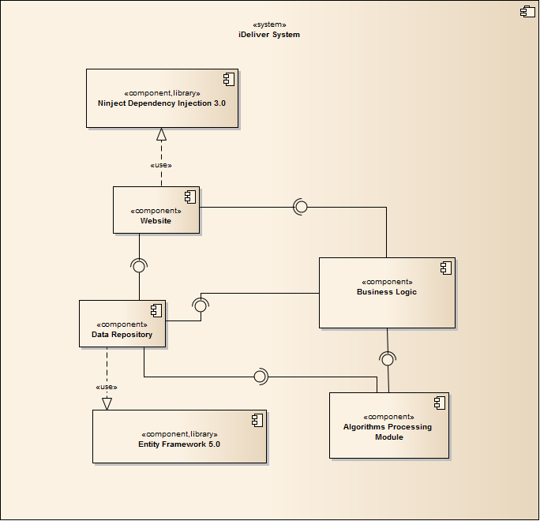

Diagram 1 Component Diagram

The MHB system includes the following major components:

* **Entity Framework 5.0:** An object-relational mapper that enables working with relational data persistence using domain-specific objects;
* **Data Repository:** A data store that provides data access functionality, using the Entity Framework to communicates with the database;
* **Data Synchronization Module:** A module that communicates with the services provided by the BMT hotel data provider and uses interfaces exposed by the Data Repository to persist the data;
* **BMT Services:** A set of web services that provide information about hotels, room types, and price changes for its consumers;
* **Business Logic:** A module that uses interfaces exposed by the Data Repository to encapsulate important businesses of in the MHB system;
* **Ninject Dependency Injection 3.0:** A lightweight dependency injection framework for .NET applications which helps split the application into a collection of loosely-coupled, highly-cohesive pieces, and then glue them back together in a flexible manner.
* **Website:** A web-application that helps exposes all the functionalities to end-users.

From the point of view of the MVC-II pattern, the components Entity Framework 5.0, Data Repository, Data Synchronization Module, BMT Services, Business Logic, and Ninject Dependency Injection 3.0 all belong to the Model part. The Controller and the View parts are wrapped in the component Website.

## Detailed Designs



### Entity Classes

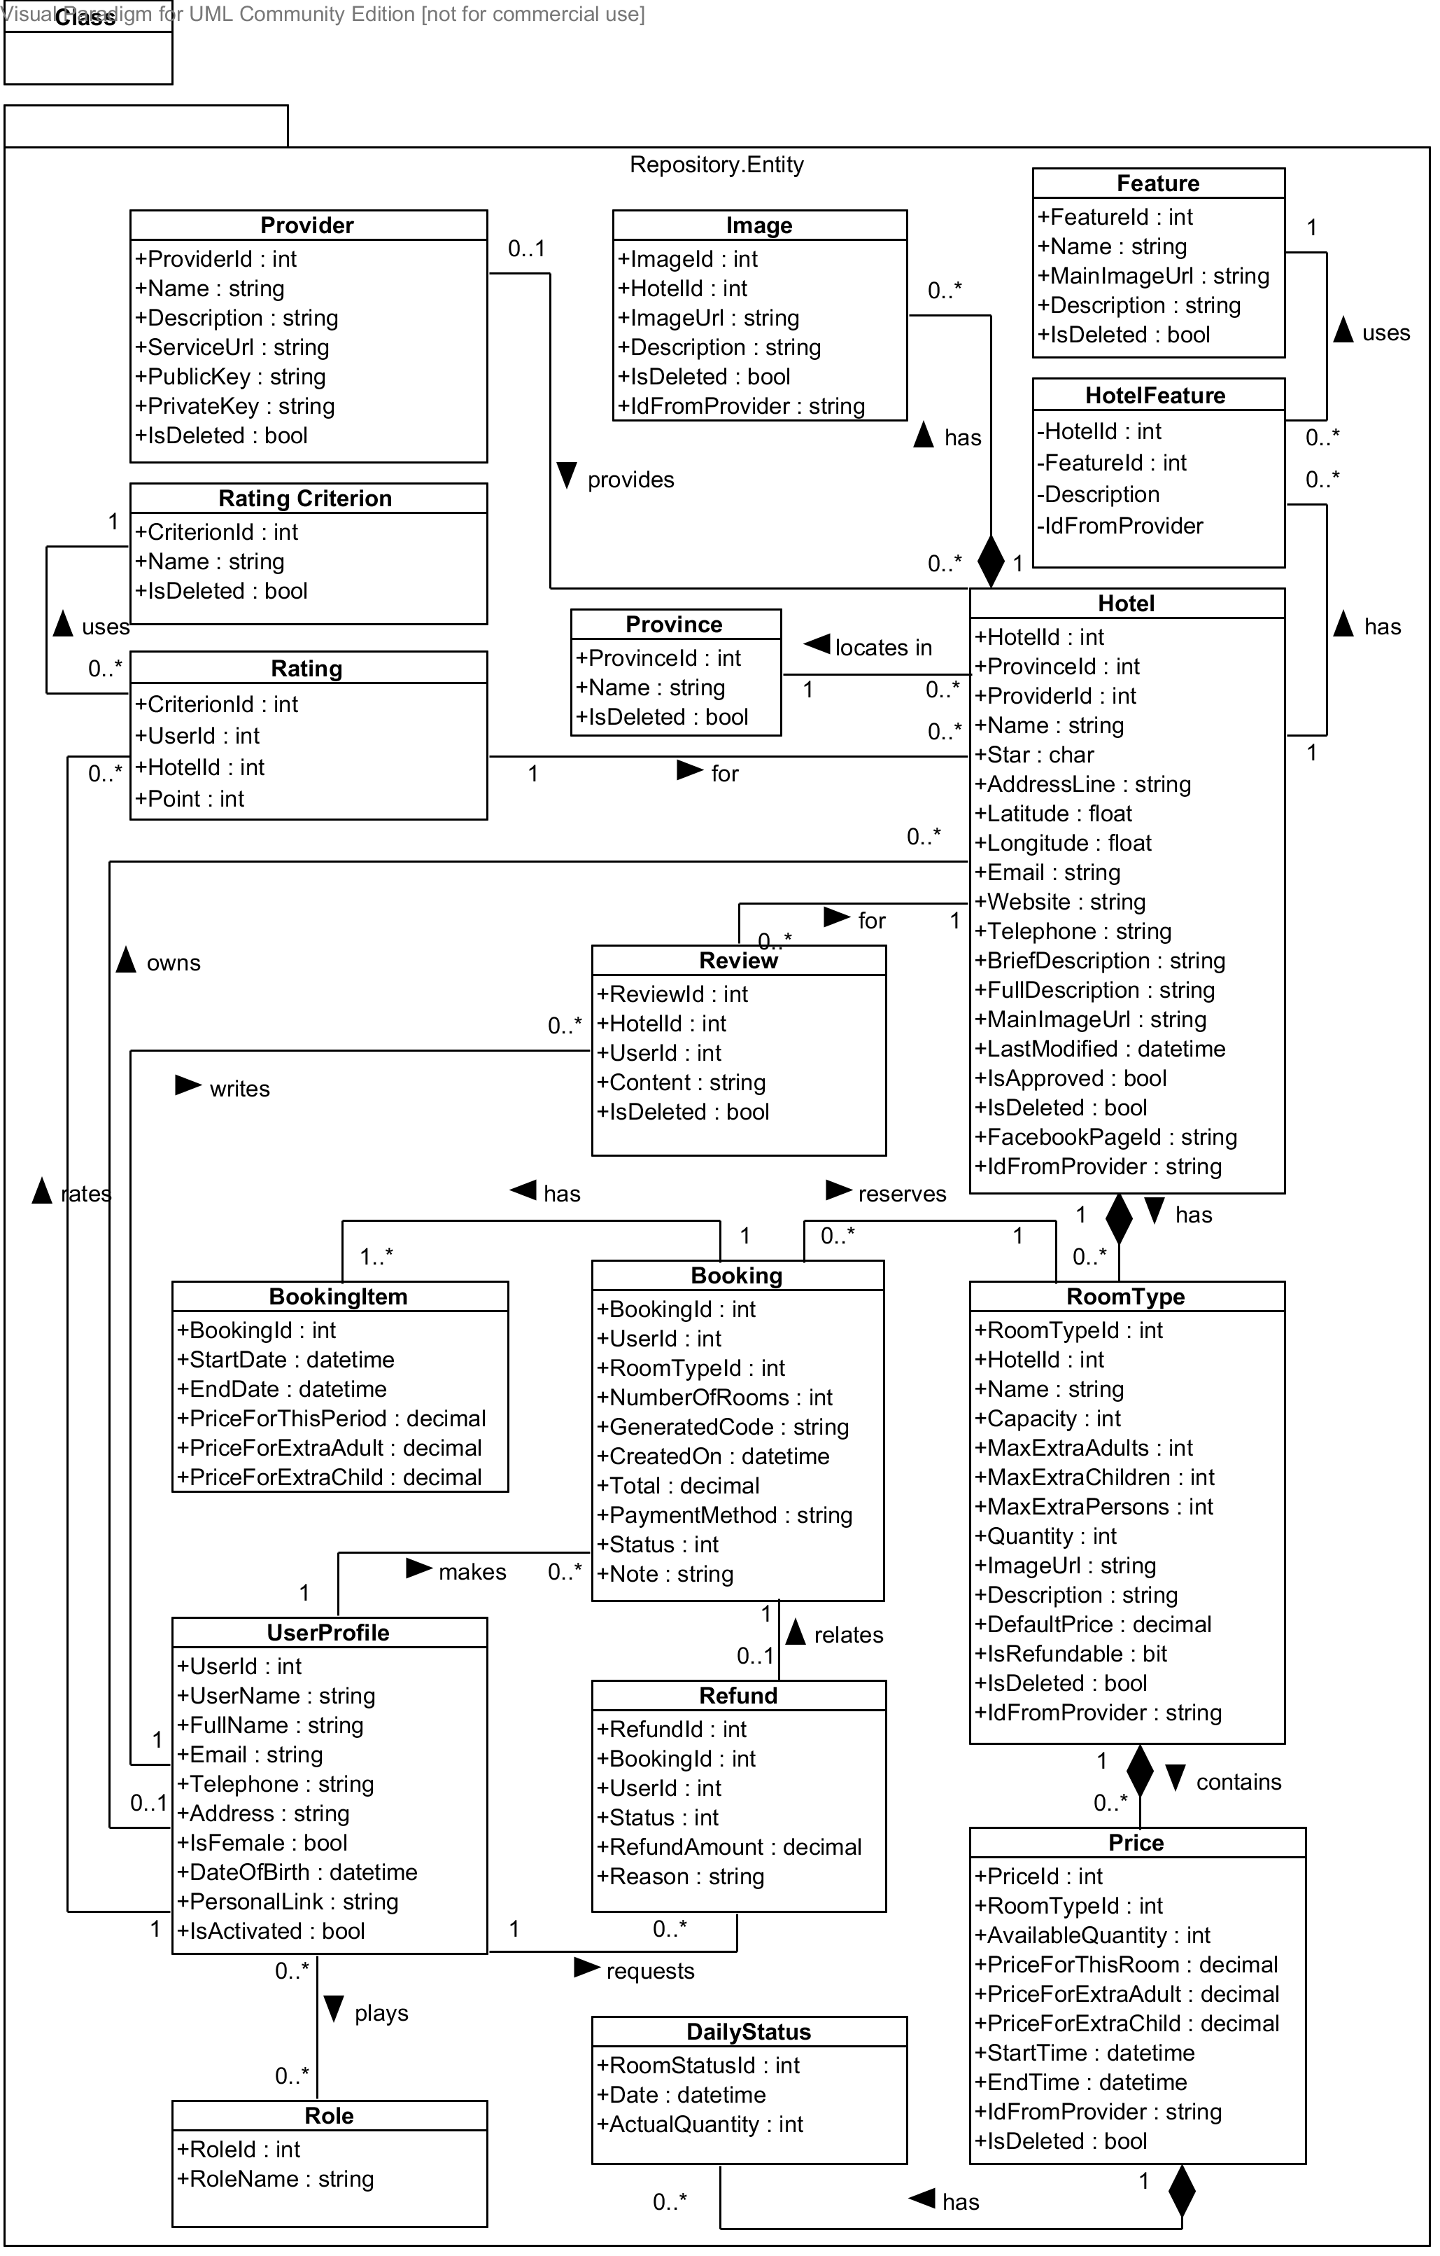

Diagram 1 Entity class diagram

#### Hotel Class

**Properties**

|  |  |  |  |
| --- | --- | --- | --- |
| Property name | Type | Visibility | Description |
| *HotelId* | int | public | Unique id that differentiates a hotel from the others |
| *ProvinceId* | int | public | Id of the province where the hotel locates in |
| *ProviderId* | int | public | Id of the hotel data provider who provides this hotel |
| *OwnerId* | int | public | Id of the hotel owner who manages this hotel |
| *Name* | string | public | Official name of the hotel |
| *Star* | char | public | International quality of the hotel |
| *AddressLine* | string | public | Address line of the hotel |
| *Latitude* | float | public | Latitude of the hotel’s address line |
| *Longitude* | float | public | Longitude of the hotel’s address line |
| *Email* | string | public | Main email address of the hotel |
| *Website* | string | public | Website address of the hotel |
| *Telephone* | string | public | Main telephone number of the hotel |
| *BriefDescription* | string | public | Short introduction about the hotel |
| *FullDescription* | string | public | Full description of the hotel |
| *MainImageUrl* | string | public | Url of the main image for the hotel |
| *LastModified* | datetime | public | Last time when the hotel’s information was modified |
| *IsApproved* | bool | public | Whether the hotel is approved or not |
| *IsDeleted* | bool | public | Whether the hotel is marked deleted or not |
| *FacebookPageId* | string | public | Id of the Facebook page that has the hotel installed as a tab |
| *IdFromProvider* | string | public | Id of the hotel if it is provided by a hotel data provider |

**Operations:** N/A

#### Feature Class

**Properties**

|  |  |  |  |
| --- | --- | --- | --- |
| Property name | Type | Visibility | Description |
| *FeatureId* | int | public | Unique id that differentiates a feature from the others |
| *Name* | string | public | Name of the hotel feature |
| *MainImageUrl* | string | public | Image url of the hotel feature |
| *Description* | string | public | Short description of the hotel feature |
| *IsDeleted* | bool | public | Whether the hotel feature is deleted or not |

**Operations:** N/A

#### Image Class

**Properties**

|  |  |  |  |
| --- | --- | --- | --- |
| Property name | Type | Visibility | Description |
| *ImageId* | int | public | Unique id that differentiates an image from the others |
| *HotelId* | int | public | Id of the hotel which the image belongs to |
| *ImageUrl* | string | public | Url of the image |
| *Description* | string | public | Description of what the image is about |
| *IdFromProvider* | string | public | Id of the image if it is provided by a hotel data provider |

**Operations:** N/A

#### Provider Class

**Properties**

|  |  |  |  |
| --- | --- | --- | --- |
| Property name | Type | Visibility | Description |
| *ProviderId* | int | public | Unique id that differentiates a provider from the others |
| *Name* | string | public | Official name of the hotel data provider |
| *Description* | string | public | Description of the services of the provider |
| *ServiceUrl* | string | public | Base url of the services provided by the hotel provider |
| *PublicKey* | string | public | Public key used to identify hotel consumer when information exchanges occur |
| *PrivateKey* | string | public | Private key that only the hotel provider and its consumer know |
| *IsDeleted* | bool | public | Where the hotel provider is deleted or not |

**Operations:** N/A

#### Province Class

**Properties**

|  |  |  |  |
| --- | --- | --- | --- |
| Property name | Type | Visibility | Description |
| *ProvinceId* | int | public | Unique id that differentiates a province from the others |
| *Name* | string | public | Name of the province in 64 provinces in Vietnam |
| *IsDeleted* | bool | public | Where the hotel province is deleted or not |

**Operations:** N/A

#### RoomType Class

**Properties**

|  |  |  |  |
| --- | --- | --- | --- |
| Property name | Type | Visibility | Description |
| *RoomTypeId* | int | public | Unique id that differentiates a room type from the others |
| *HotelId* | int | public | Id of the hotel which the room type belongs to |
| *Name* | string | public | Official name of the room type specified by the hotel owner |
| *Capacity* | int | public | Default value of the number of persons who can stay in the room |
| *MaxExtraAdults* | int | public | Number of maximum extra children, if any |
| *MaxExtraChildren* | int | public | Number of maximum extra adults, if any |
| *MaxExtraPersons* | int | public | Number of maximum extra person, if any |
| *Quantity* | int | public | Number of physical rooms of this type in the hotel |
| *ImageUrl* | string | public | Main url of the image for the room type |
| *Description* | string | public | Description of the room type |
| *DefaultPrice* | decimal | public | Default price for the room type |
| *IsRefundable* | bool | public | Whether the rooms of this type can be refunded or not |
| *IsDeleted* | bool | public | Whethere the room type is deleted or not |
| *IdFromProvider* | string | public | Id of the room type if it is provided by a hotel provider |

**Operations:** N/A

#### Price Class

**Properties**

|  |  |  |  |
| --- | --- | --- | --- |
| Property name | Type | Visibility | Description |
| *PriceId* | int | public | Unique id that differentiates a price from the others |
| *RoomTypeId* | int | public | Id of the room type that this price belongs to |
| *AvailableQuantity* | int | public | Number of available rooms for this room type in the period specified |
| *PriceForThisRoom* | decimal | public | Price for this room in the period specified |
| *PriceForExtraAdult* | decimal | public | Price for an extra adult, if any |
| *PriceForExtraChild* | decimal | public | Price for an extra child, if any |
| *StartTime* | datetime | public | Date on which the price becomes active |
| *EndTime* | datetime | public | Date on which the price becomes inactive |
| *IdFromProvider* | string | public | Id of the price if it is provided by a hotel provider |
| *IsDeleted* | bool | public | Whethere the price is deleted or not |

**Operations:** N/A

#### DailyStatus Class

**Properties**

|  |  |  |  |
| --- | --- | --- | --- |
| Property name | Type | Visibility | Description |
| *PriceId* | int | public | Id of the price that this daily status belongs to |
| *Date* | datetime | public | Date on which this daily status takes place |
| *ActualQuantity* | int | public | Actual available number of rooms on the day when the daily status takes place |

**Operations:** N/A

#### UserProfile Class

**Properties**

|  |  |  |  |
| --- | --- | --- | --- |
| Property name | Type | Visibility | Description |
| *UserId* | int | public | Unique id that differentiates a user from the others |
| *Username* | string | public | Unique name that will be use to log in the system |
| *FullName* | string | public | Full name of the user |
| *Email* | string | public | Email address of the user |
| *Telephone* | string | public | Telephone number of the user |
| *Address* | string | public | Address line of the user |
| *IsFemale* | bool | public | Whether the user is female or male |
| *DateOfBirth* | datetime | public | Date of birth of the user |
| *PersonalLink* | string | public | Personal website of the user |
| *IsActivated* | bool | public | Whether the user is activated on the MHB system or not |

**Operations:** N/A

#### Booking Class

**Properties**

|  |  |  |  |
| --- | --- | --- | --- |
| Property name | Type | Visibility | Description |
| *BookingId* | int | public | Unique id that differentiates a hotel from the others |
| *UserId* | int | public | Id of the user who makes the booking |
| *RoomTypeId* | int | public | Id of the room type booked by the user |
| *NumberOfRooms* | int | public | Number of rooms the user booked for this room type |
| *ExtraAdults* | int | public | Number of extra adults, if any |
| *ExtraChildren* | int | public | Number of extra children, if any |
| *GeneratedCode* | string | public | String that whill be used to verify with the hotel when the user checks in |
| *CreatedOn* | datetime | public | Time when the booking is created |
| *Total* | decimal | public | Total amount of the booking order |
| *PaymentMethod* | string | public | Method which the user uses to pay for the booking |
| *Status* | int | public | Status of the booking |
| *Note* | string | public | Additional note the user specifies for the hotel |

**Operations:** N/A

#### Refund Class

**Properties**

|  |  |  |  |
| --- | --- | --- | --- |
| Property name | Type | Visibility | Description |
| *RefundId* | int | public | Unique id that differentiates a refund from the others |
| *BookingId* | int | public | Id of the booking which the refunds relates |
| *UserId* | int | public | Id of the user who requests the refund |
| *Status* | int | public | Status of the refund request |
| *RefundAmount* | decimal | public | Amount that will be refunded to the user |
| *Reason* | string | public | Reason why the user wants the hotel to refund the bookings |

**Operations:** N/A

#### Role Class

**Properties**

|  |  |  |  |
| --- | --- | --- | --- |
| Property name | Type | Visibility | Description |
| *RoleId* | int | public | Unique id that differentiates a role from the others |
| *RoleName* | string | public | Name of the role |

**Operations:** N/A

#### BookingItem Class

**Properties**

|  |  |  |  |
| --- | --- | --- | --- |
| Property name | Type | Visibility | Description |
| *BookingId* | int | public | The id of the booking which this booking item belongs to |
| *StartDate* | datetime | public | Date on which a booking item starts |
| *EndDate* | datetime | public | Date on which a booking item ends |
| *PriceForThisPeriod* | decimal | public | Price for the room in the period specified |
| *PriceForExtraAdult* | decimal | public | Price for an extra adult in the period specified, if any |
| *PriceForExtraChild* | decimal | public | Price for an extra child in the period specified, if any |

**Operations:** N/A

#### Review Class

**Properties**

|  |  |  |  |
| --- | --- | --- | --- |
| Property name | Type | Visibility | Description |
| *ReviewId* | int | public | Unique id that differentiates a review from the others |
| *HotelId* | int | public | Id of the hotel that the review is about |
| *UserId* | int | public | Id of the user who writes the review |
| *Content* | string | public | Content of the review written by the user |
| *IsDeleted* | bool | public | Whether the review is deleted or not |

**Operations:** N/A

#### Rating Class

**Properties**

|  |  |  |  |
| --- | --- | --- | --- |
| Property name | Type | Visibility | Description |
| *CriterionId* | int | public | Id of the criterion being rated by the user |
| *UserId* | int | public | Id of the user who rates the hotel |
| *HotelId* | int | public | Id of the hotel being rated by the user |
| *Point* | int | public | Point that the user gives the hotel for the selected criterion |

**Operations:** N/A

#### RatingCriterion Class

**Properties**

|  |  |  |  |
| --- | --- | --- | --- |
| Property name | Type | Visibility | Description |
| *CriterionId* | int | public | Unique id that differentiates a criterion from the others |
| *Name* | int | public | Name of the criterion used to rate the hotels |
| *IsDeleted* | int | public | Whether the criterion is deleted or not |

**Operations:** N/A



### Repository Classes



#### Class diagram

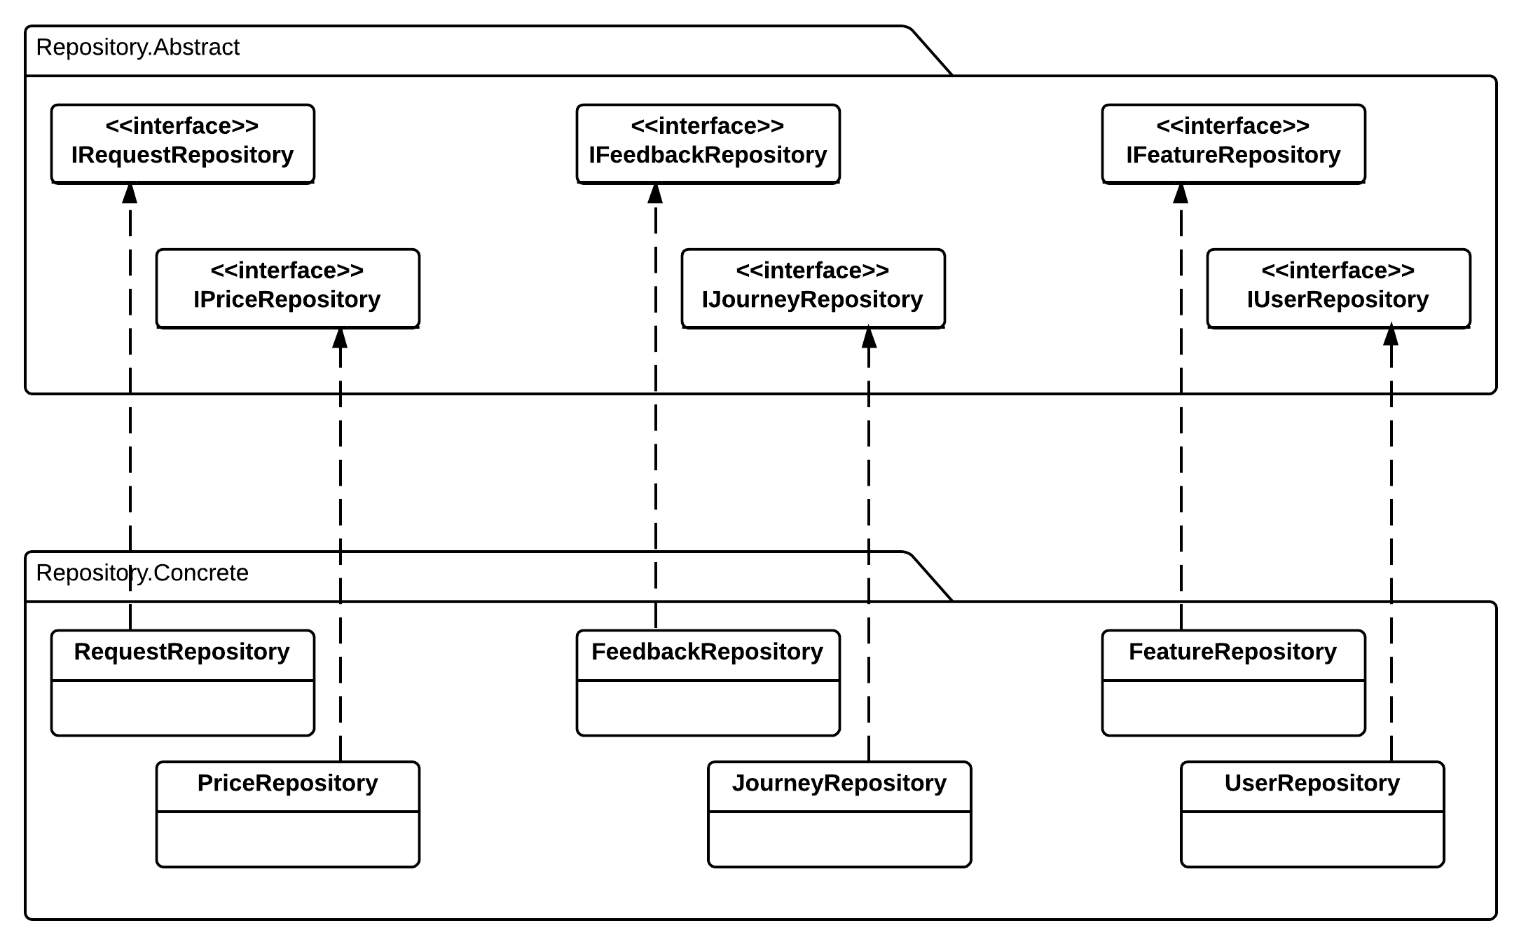

#### IRequestRepository Interface

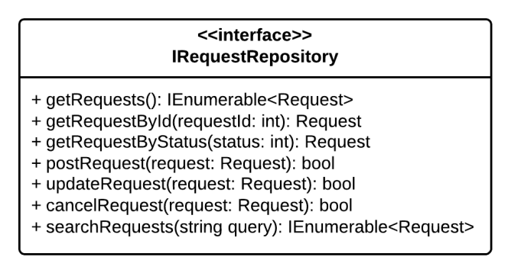

**Properties:** N/A

**Operations**

|  |  |  |
| --- | --- | --- |
| Signature: IEnumerable<Hotel> GetHotels()  Description: Retrieves all the hotels from the database | | |
| N/A | N/A | N/A |

|  |  |  |
| --- | --- | --- |
| Signature: Hotel GetHotelById(int hotelId)  Description: Retrieves a hotel from the database given its id | | |
| Parameter | **Type** | **Description** |
| *hotelId* | int | Id of the hotel to be retrieved |

|  |  |  |
| --- | --- | --- |
| Signature: IEnumerable<Hotel> GetHotelByFacebookPageId(string pageId)  Description: Retrieves a from the database given its Facebook page id | | |
| Parameter | **Type** | **Description** |
| *pageId* | string | Id of the Facebook page of the hotel |
|  |  |  |

|  |  |  |
| --- | --- | --- |
| Signature: Hotel GetHotelByIdFromProvider(int providerId, string hotelId)  Description: Retrieves all the hotels provided by a given provider from the database | | |
| Parameter | **Type** | **Description** |
| *providerId* | int | Id of the provider that provides the hotel |
| *hotelId* | string | Id given by the provider for the hotel |

|  |  |  |
| --- | --- | --- |
| Signature: IEnumerable<Hotel> GetHotelsByOwnerId(int userId)  Description: Retrieves all the hotels under the management of a hotel owner from the database | | |
| Parameter | **Type** | **Description** |
| *userId* | int | Id of the hotel owner |

|  |  |  |
| --- | --- | --- |
| Signature: IEnumerable<Feature> GetHotelFeatures(int hotelId)  Description: Retrieves all features of a given hotel from the database | | |
| Parameter | **Type** | **Description** |
| *hotelId* | int | Id of the hotel to be retrieved |

|  |  |  |
| --- | --- | --- |
| Signature: bool SaveHotel(Hotel hotel)  Description: Saves (insert or update) a hotel to the database | | |
| Parameter | **Type** | **Description** |
| *hotel* | Hotel | Id of the hotel to be saved |

|  |  |  |
| --- | --- | --- |
| Signature: bool CheckQuality(int hotelId)  Description: Check if the hotel with the given id has enough information | | |
| Parameter | **Type** | **Description** |
| *provinceId* | int | Id of the hotel to be checked |

|  |  |  |
| --- | --- | --- |
| Signature: bool SaveImage(int hotelId, string url)  Description: Save an image for the given hotel to the database | | |
| Parameter | **Type** | **Description** |
| *hotelId* | int | Id of the hotel to be saved |
| *url* | string | Url of the image to be saved |

|  |  |  |
| --- | --- | --- |
| Signature: bool SaveFacebookPageId(int hotelId, string facebookPageId)  Description: Save a Facebook page for a given hotel to the database | | |
| Parameter | **Type** | **Description** |
| *hotelId* | int | Id of the hotel to be saved |
| *facebookPageId* | string | Id of the Facebook page provided by Facebook |

|  |  |  |
| --- | --- | --- |
| Signature: bool ApproveHotel(int hotelId)  Description: Approves a hotel to set it active in the system | | |
| Parameter | **Type** | **Description** |
| *hotelId* | int | Id of the hotel to be approved of |

|  |  |  |
| --- | --- | --- |
| Signature: bool DeleteHotel(int hotelId)  Description: Marks a hotel as deleted given its id in the database | | |
| Parameter | **Type** | **Description** |
| *hotelId* | int | Id of the hotel to be deleted |

|  |  |  |
| --- | --- | --- |
| Signature: IEnumerable<Hotel> SearchHotels(float lat, float long, datetime from, datetime to, int radius, string sortBy, Filter filters)  Description: Retrieves all the hotels that satisfy the criteria specified in the parameters from the database | | |
| Parameter | **Type** | **Description** |
| *lat* | float | Latitude of the center of the destination |
| *long* | float | Longitude of the center of the destination |
| *from* | datetime | Date to check prices from |
| *to* | datetime | Date to check prices to |
| *radius* | int | Radius to be search from the center of the destination |
| *sortBy* | string | Order in which the results should be |
| *filters* | Filter | Filters applied to the results |

|  |  |  |
| --- | --- | --- |
| Signature: IEnumerable<Hotel> SearchHotels(string query)  Description: Retrieves all the hotels that contains the query string in its name and address line from the database | | |
| Parameter | **Type** | **Description** |
| *query* | string | Query used to search for hotel name and address line |

|  |  |  |
| --- | --- | --- |
| Signature: IEnumerable<Hotel> GetHotelsByProvinceId(int provinceId)  Description: Retrieves all the hotels from the database | | |
| Parameter | **Type** | **Description** |
| *provinceId* | int | Id of the province that has its hotels to be retrieved |

#### IFeatureRepository Interface

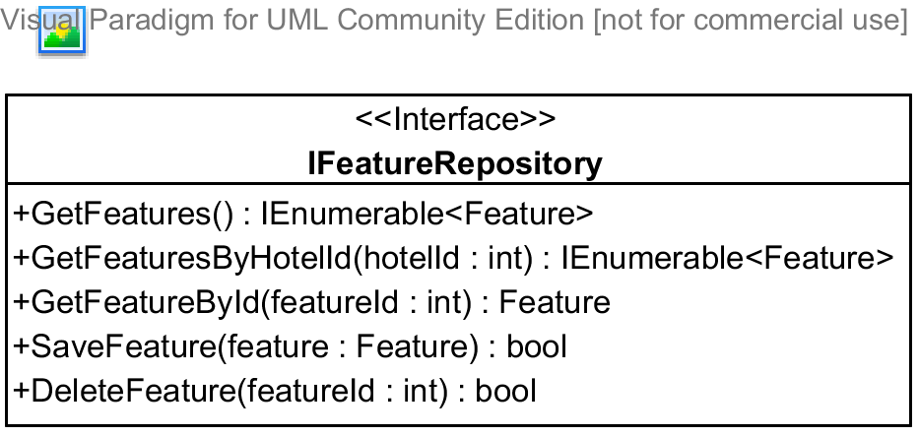

**Properties:** N/A

**Operations**

|  |  |  |
| --- | --- | --- |
| Signature: IEnumerable<Feature> GetFeatures()  Description: Retrieves all the hotel features from the database | | |
| Parameter | **Type** | **Description** |
| N/A | N/A | N/A |

|  |  |  |
| --- | --- | --- |
| Signature: IEnumerable<Feature> GetFeaturesByHotelId(int hotelId)  Description: Retrieves all the hotel features for a given hotel from the database | | |
| Parameter | **Type** | **Description** |
| *hotelId* | int | Id of the hotel that has the features to be retrieved |

|  |  |  |
| --- | --- | --- |
| Signature: Feature GetFeatureById(int featureId)  Description: Retrieves a feature given its id from the database | | |
| Parameter | **Type** | **Description** |
| *featureId* | int | Id of the feature to be retrieved |

|  |  |  |
| --- | --- | --- |
| Signature: bool SaveFeature(Feature feature)  Description: Saves (insert or update) the feature to the database | | |
| Parameter | **Type** | **Description** |
| *feature* | Feature | The feature to be saved |

|  |  |  |
| --- | --- | --- |
| Signature: bool DeletedFeature(int featureId)  Description: Marks the feature as deleted int the database | | |
| Parameter | **Type** | **Description** |
| *featureId* | int | Id of the feature to be deleted |

#### IPriceRepository Interface

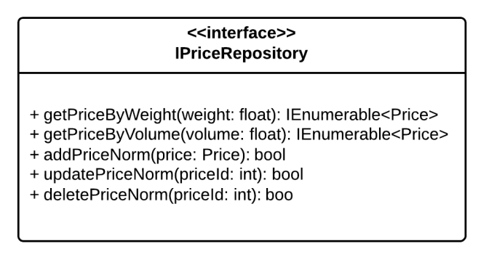

**Properties:** N/A

**Operations**

|  |  |  |
| --- | --- | --- |
| Signature: IEnumerable<Price> GetPriceByRoomTypeId(int roomTypeid)  Description: Retrieves all the prices given its room type from the database | | |
| Parameter | **Type** | **Description** |
| *roomTypeId* | int | Id of the room type that has its prices to be retrieved |

|  |  |  |
| --- | --- | --- |
| Signature: IEnumerable<DailyStatus> GetDailyStatusesByPriceId(int priceId)  Description: Retrieves all the daily status for a given price from the database | | |
| Parameter | **Type** | **Description** |
| *priceId* | int | Id of the price that has the daily statuses to be retrieved |

|  |  |  |
| --- | --- | --- |
| Signature: Price GetPriceById(int priceId)  Description: Retrieves a price given its id from the database | | |
| Parameter | **Type** | **Description** |
| *priceId* | int | Id of price to be retrieved |

|  |  |  |
| --- | --- | --- |
| Signature: bool SavePrice(Price price)  Description: Saves (insert or update) a price to the database | | |
| Parameter | **Type** | **Description** |
| *price* | Price | The price to be saved |

|  |  |  |
| --- | --- | --- |
| Signature: bool SaveDailyStatus(DailyStatus status)  Description: Saves (insert or update) a daily status in the database | | |
| Parameter | **Type** | **Description** |
| *status* | DailyStatus | The daily status to be saved |

|  |  |  |
| --- | --- | --- |
| Signature: bool DeletedPrice(int priceId)  Description: Marks the price as deleted int the database | | |
| Parameter | **Type** | **Description** |
| *priceId* | int | Id of the price to be deleted |

|  |  |  |
| --- | --- | --- |
| Signature: bool IsOverlapping(int roomTypeId, datetime start, datetime end)  Description: Checks if there is a price that overlaps the specified period for the given room type in the database | | |
| Parameter | **Type** | **Description** |
| *roomTypeId* | int | Id of room type to be checked |
| *start* | DateTime | Date on which the price starts |
| *end* | DateTime | Date on which the price ends |

|  |  |  |
| --- | --- | --- |
| Signature: bool GetPriceByIdFromProvider(int providerId, string id)  Description: Retrieves a price given the id provided by the provider from the database | | |
| Parameter | **Type** | **Description** |
| *providerId* | int | Id of the provider who provides the price |
| *id* | string | Id given by the provider |

#### IFeedbackRepository Interface

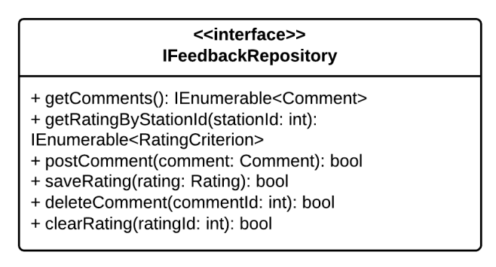

**Properties:** N/A

**Operations**

|  |  |  |
| --- | --- | --- |
| Signature: IEnumerable<RoomType> GetRoomTypes()  Description: Retrieves all the room types from the database | | |
| Parameter | **Type** | **Description** |
| N/A | N/A | N/A |

|  |  |  |
| --- | --- | --- |
| Signature: IEnumerable<RoomType> GetRoomTypeByHotelId(int hotelId)  Description: Retrieves all the room types that belong to a given hotel from the database | | |
| Parameter | **Type** | **Description** |
| *hotelId* | int | Id of the hotel that has the room types to be retrieved |

|  |  |  |
| --- | --- | --- |
| Signature: Feature GetRoomTypeById(int roomTypeId)  Description: Retrieves a room type given its id from the database | | |
| Parameter | **Type** | **Description** |
| *roomTypeId* | int | Id of the room type to be retrieved |

|  |  |  |
| --- | --- | --- |
| Signature: bool SaveRoomType(RoomType room)  Description: Saves (insert or update) the room type to the database | | |
| Parameter | **Type** | **Description** |
| *room* | RoomType | The room type to be saved |

|  |  |  |
| --- | --- | --- |
| Signature: bool DeletedRoomType(int roomTypeId)  Description: Marks a room type as deleted int the database | | |
| Parameter | **Type** | **Description** |
| *roomTypeId* | int | Id of the room type to be deleted |

#### IJourneyRepository Interface

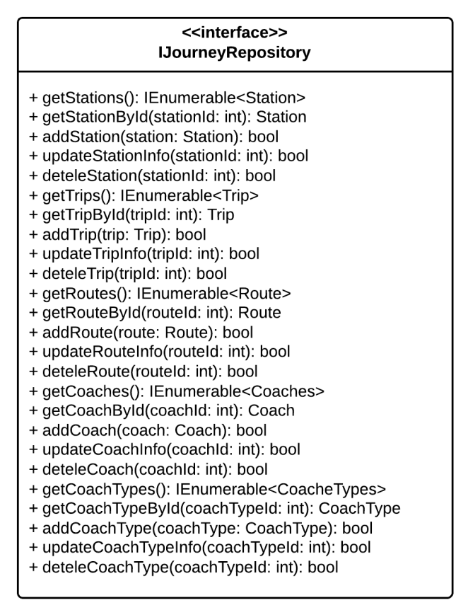

**Properties:** N/A

**Operations**

|  |  |  |
| --- | --- | --- |
| Signature: IEnumerable<Reviews> GetReviews()  Description: Retrieves all the reviews from the database | | |
| Parameter | **Type** | **Description** |
| N/A | N/A | N/A |

|  |  |  |
| --- | --- | --- |
| Signature: IEnumerable<Review> GetReviewByHotelId(int hotelId)  Description: Retrieves all the reviews given its hotel id from the database | | |
| Parameter | **Type** | **Description** |
| *hotelId* | int | Id of the hotel that has its reviews to be retrieved |

|  |  |  |
| --- | --- | --- |
| Signature: Feature GetRatingCriteria()  Description: Retrieves a rating criteria from the database | | |
| Parameter | **Type** | **Description** |

|  |  |  |
| --- | --- | --- |
| Signature: Feature GetReviewById(int reviewId)  Description: Retrieves a review given its id from the database | | |
| Parameter | **Type** | **Description** |
| *reviewId* | int | Id of the review to be retrieved |

|  |  |  |
| --- | --- | --- |
| Signature: bool SaveCriterion(Criterion criterion)  Description: Saves (insert or update) the criterion to the database | | |
| Parameter | **Type** | **Description** |
| *criterion* | Criterion | The criterion to be saved |

|  |  |  |
| --- | --- | --- |
| Signature: bool SaveReview(Review review)  Description: Saves (insert or update) the feature to the database | | |
| Parameter | **Type** | **Description** |
| *review* | Review | The review to be saved |

|  |  |  |
| --- | --- | --- |
| Signature: bool DeletedReview(int reviewId)  Description: Marks the review as deleted int the database | | |
| Parameter | **Type** | **Description** |
| *reviewId* | int | Id of the review to be deleted |

|  |  |  |
| --- | --- | --- |
| Signature: bool DeletedCriterion(int criterionId)  Description: Marks the criterion as deleted int the database | | |
| Parameter | **Type** | **Description** |
| *criterionId* | int | Id of the criterion to be deleted |

|  |  |  |
| --- | --- | --- |
| Signature: bool SaveRating(int userId, int hotelId, int criterionId, int point)  Description: Marks the review as deleted int the database | | |
| Parameter | **Type** | **Description** |
| *userId* | int | Id of user who rated the hotel |
| *hotelId* | int | Id of the hotel being rated |
| *criterionId* | int | Id of the criterion being rated |
| *point* | int | Point the user gives to the hotel for the criterion |

#### IUserRepository Interface

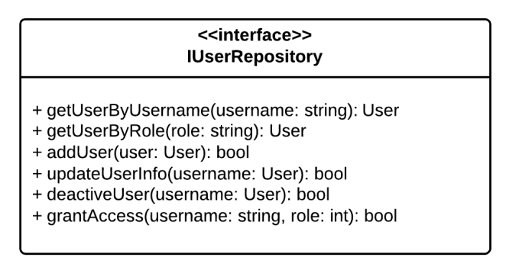

**Properties:** N/A

**Operations**

|  |  |  |
| --- | --- | --- |
| Signature: UserProfile GetUserById(int userId)  Description: Retrieves a user given its id from the database | | |
| Parameter | **Type** | **Description** |
| *userId* | int | Id of user to be retrieved |

|  |  |  |
| --- | --- | --- |
| Signature: UserProfile GetUserByUsername(string username)  Description: Retrieves a user given its username from the database | | |
| Parameter | **Type** | **Description** |
| *username* | int | User of user to be retrieved |

|  |  |  |
| --- | --- | --- |
| Signature: bool SaveUser(UserProfile user)  Description: Saves (insert or update) the feature to the database | | |
| Parameter | **Type** | **Description** |
| *user* | UserProfile | The user to be saved |

|  |  |  |
| --- | --- | --- |
| Signature: bool DeactivateUser(int userId)  Description: Marks the the user as deactivated in the database | | |
| Parameter | **Type** | **Description** |
| *userId* | int | Id of the user to be marked as deactivated |

|  |  |  |
| --- | --- | --- |
| Signature: bool GrantAccess(int userId, int roleId)  Description: Grants the selected role the the user with the user id | | |
| Parameter | **Type** | **Description** |
| *userId* | int | Id of the user to be granted access |
| *roleId* | Role | Role that will be granted to the user |

|  |  |  |
| --- | --- | --- |
| Signature: bool DeactivateUser(int userId)  Description: Marks the the user as deactivated in the database | | |
| Parameter | **Type** | **Description** |
| *userId* | int | Id of the user to be marked as deactivated |

### Algoritms Processing Classes



#### Class diagram

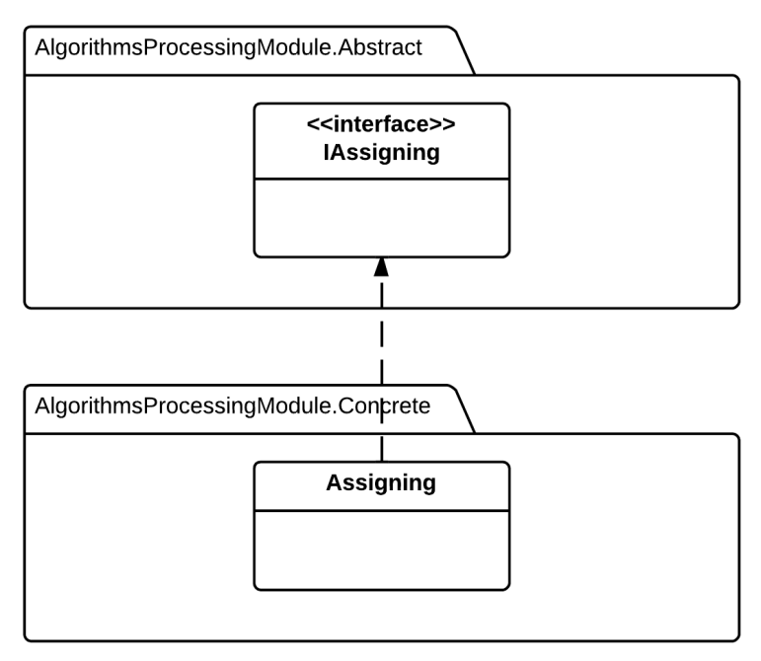

#### IHotelSyncher Interface

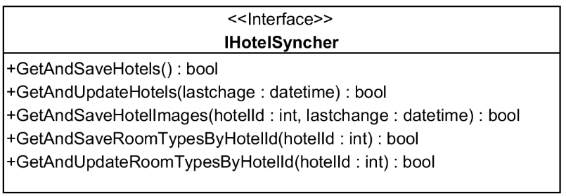

**Properties:** N/A

**Operations**

|  |  |  |
| --- | --- | --- |
| Signature: bool GetAndSaveHotels()  Description: Retrieves all the hotels provided by the BMT provider and save them the the database | | |
| Parameter | **Type** | **Description** |
| N/A | N/A | N/A |

|  |  |  |
| --- | --- | --- |
| Signature: bool GetAndUpdateHotels(datetime lastChange)  Description: Updates all the hotels provided by the BMT provider by calling its services and then saving the updated information to the database. | | |
| Parameter | **Type** | **Description** |
| *lastChange* | DateTime | Time on which the last change was made on the data |

|  |  |  |
| --- | --- | --- |
| Signature: bool GetAndSaveHotelImages(int hotelId, datetime lastChange)  Description: Retrieves all the images of the given hotel provided by the BMT provider and save them the the database. | | |
| Parameter | **Type** | **Description** |
| *lastChange* | datetime | Time on which the last change was made on the data |
| *hotelId* | int | Id of the hotel to be updated |

|  |  |  |
| --- | --- | --- |
| Signature: bool GetAndSaveHotelImages(int hotelId)  Description: Retrieves all the room types of the given hotel provided by the BMT provider and save them the the database. | | |
| Parameter | **Type** | **Description** |
| *hotelId* | int | Id of the hotel to be updated |

|  |  |  |
| --- | --- | --- |
| Signature: bool GetAndUpdatesHotelImages(int hotelId)  Description: Updates all the room types of the selected hotel provided by the BMT provider by calling its services and then saving the updated information to the database. | | |
| Parameter | **Type** | **Description** |
| *hotelId* | int | Id of the hotel to be updated |

#### IPriceSyncher

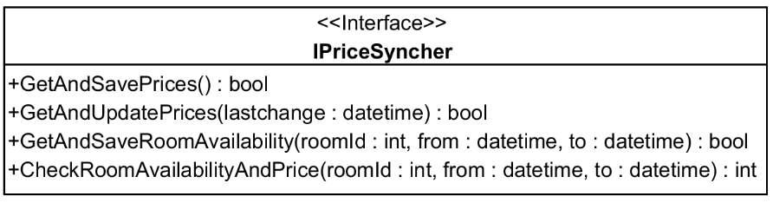

**Properties:** N/A

**Operations**

|  |  |  |
| --- | --- | --- |
| Signature: bool GetAndSavePrices(int hotelId)  Description: Retrieves all the prices of all the hotels provided by the BMT provider and save them the the database. | | |
| Parameter | **Type** | **Description** |
| N/A | N/A | N/A |

|  |  |  |
| --- | --- | --- |
| Signature: bool GetAndUpdatePrices(lastchange: datetime)  Description: Updates all prices of the the hotels provided by the BMT provider by calling its services and then saving the updated information to the database. | | |
| Parameter | **Type** | **Description** |
| *lastChange* | datetime | Time on which the last change was made on the data |

|  |  |  |
| --- | --- | --- |
| Signature: bool GetAndSaveRoomAvailability(int hotelId)  Description: Retrieves all the room availability statuses of the selected room type provided by the BMT provider and save them the the database. | | |
| Parameter | **Type** | **Description** |
| *roomId* | int | Id of the room to be updated |
| *from* | datetime | Date on which the checking starts |
| *to* | datetime | Date on which the checking ends |

|  |  |  |
| --- | --- | --- |
| Signature: int CheckRoomAvailabilityAndPrice(int roomId, int quantity, datetime from, datetime to)  Description: Checks if the room type is avaible on the specified period and retrieves its price if it is available. | | |
| Parameter | **Type** | **Description** |
| *roomId* | int | Id of the room to be checked |
| *quantity* | int | Number of rooms to check |
| *from* | datetime | Date on which the checking starts |
| *to* | datetime | Date on which the checking ends |

#### IBookingSyncher Interface

#### IBookingSyncher Interface

### Business Logic Classes



#### Class diagram

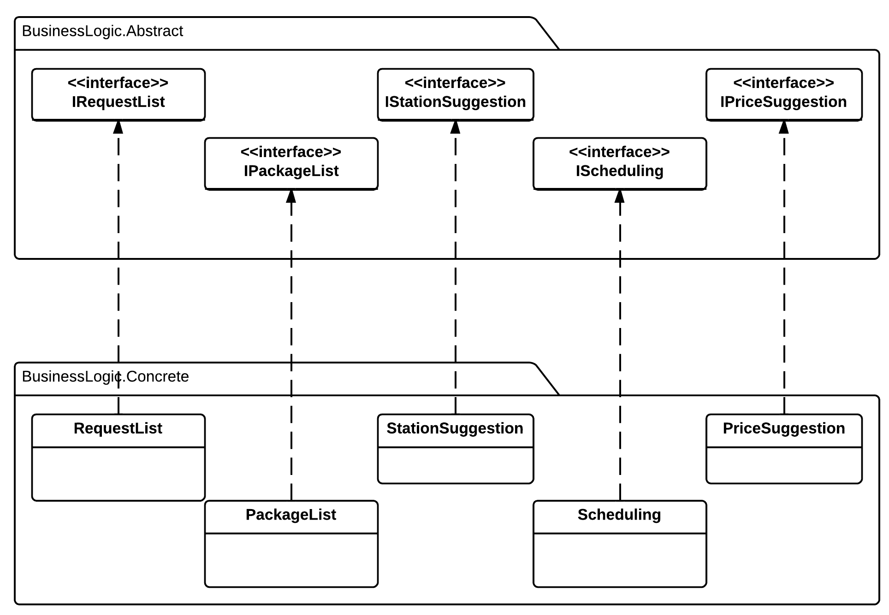

#### IRequestList Interface

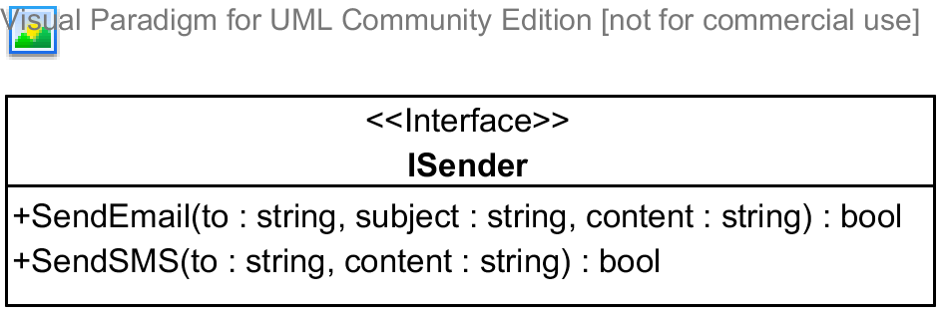

**Properties:** N/A

**Operations**

|  |  |  |
| --- | --- | --- |
| Signature: bool SendEmail(string to, string subject, string content)  Description: Sends an email to the address specified | | |
| Parameter | **Type** | **Description** |
| *to* | string | The email address to send to |
| *subject* | string | The subject of the email |
| *content* | string | The content of the email |

|  |  |  |
| --- | --- | --- |
| Signature: bool SendSMS(string to, string content)  Description: Sends an SMS message to the address specified | | |
| Parameter | **Type** | **Description** |
| *to* | string | The telephone number to send to |
| *content* | string | The content of the message |

#### IStationSuggestion Interface

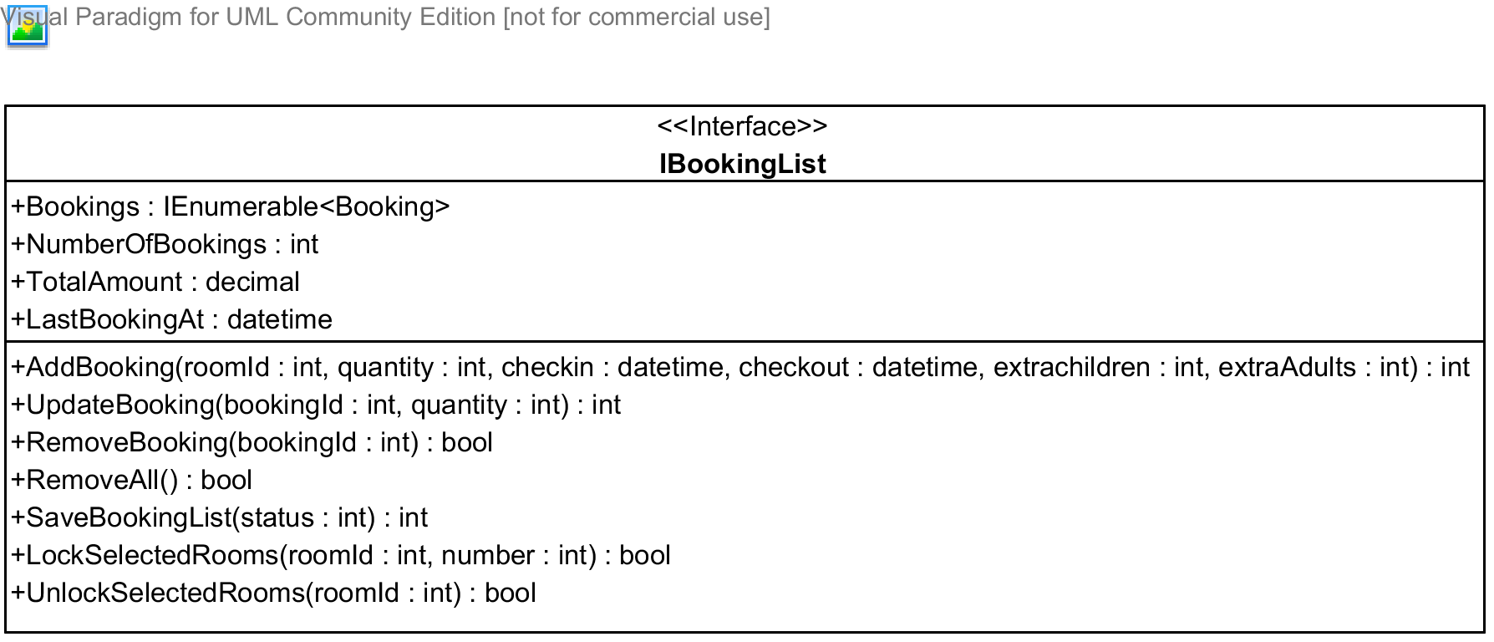

**Properties**

|  |  |  |  |
| --- | --- | --- | --- |
| Property name | Type | Visibility | Description |
| *Bookings* | IEnumerable<Booking> | public | A list of all bookings in the booking list for the current user |
| *NumberOfBooking* | int | public | Number of bookings in the booking list |
| *TotalAmount* | decimal | public | Total amount of all the booking |
| *LastBookingAt* | datetime | public | Time when the last booking was added to the booking list |

**Operations**

|  |  |  |
| --- | --- | --- |
| Signature: int AddBooking(int roomId, int quantity, datetime checkin, datetime checkout, int extraChildren, int extraAdults)  Description: Adds a bookings made by the current user to the booking list | | |
| Parameter | **Type** | **Description** |
| *roomId* | int | Id of room type being booked |
| *quantity* | int | Numbers of rooms needed |
| *checkin* | datetime | Check-in date |
| *checkout* | datetime | Check-out date |
| *extraChildren* | int | Number of extra children, if allowed by the hotel owner |
| *extraAdults* | int | Number of extra adults, if allowed by the hotel owner |

|  |  |  |
| --- | --- | --- |
| Signature: int UpdateBooking(int bookingId, int quantity)  Description: Update a booking in the booking list given its id | | |
| Parameter | **Type** | **Description** |
| *bookingId* | int | Id of the booking to be updated |
| *quantity* | int | Number of rooms to be updated |

|  |  |  |
| --- | --- | --- |
| Signature: bool RemoveBooking(int bookingId)  Description: Removed a booking in the booking list given its id | | |
| Parameter | **Type** | **Description** |
| *bookingId* | int | Id of the booking to be removed |

|  |  |  |
| --- | --- | --- |
| Signature: bool RemoveAll(int bookingId)  Description: Removed all the bookings int the booking list | | |
| Parameter | **Type** | **Description** |

|  |  |  |
| --- | --- | --- |
| Signature: bool SaveBookingList(int status)  Description: Saves the booking list to the database | | |
| Parameter | **Type** | **Description** |
| *status* | int | Status of the bookings to be saved |

|  |  |  |
| --- | --- | --- |
| Signature: bool LockSelectedRooms(int roomId, int number)  Description: Locks the rooms selected so that other user cannot book these rooms | | |
| Parameter | **Type** | **Description** |
| *roomId* | int | Id of the room type to be locked |
| *number* | int | Number of rooms to be locked for this type |

|  |  |  |
| --- | --- | --- |
| Signature: bool UnlockSelectedRooms(int roomId)  Description: Unlocks the rooms selected so that other user can book these rooms | | |
| Parameter | **Type** | **Description** |
| *roomId* | int | Id of the room type to be unlocked |

#### IPriceSuggestion Interface

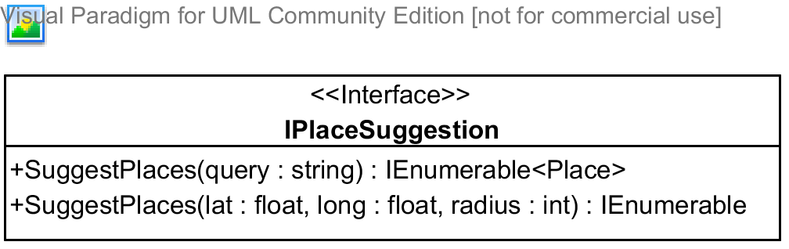

**Properties:** N/A

**Operations**

|  |  |  |
| --- | --- | --- |
| Signature: IEnumerable<Place> SuggestPlaces(string query)  Description: Suggests places(hotel address, provinces, and other type of places,...) given a query string | | |
| Parameter | **Type** | **Description** |
| *query* | string | A string that will be used to search and suggest places |

|  |  |  |
| --- | --- | --- |
| Signature: IEnumerable<Place> SuggestPlaces(float lat, float long, int radius)  Description: Suggests places(hotel address, provinces, and other type of places,...) given the center of the destination and the radius to be searched | | |
| Parameter | **Type** | **Description** |
| *lat* | float | Latitude of the destination center |
| *long* | float | Longitude of the destination center |
| *radius* | int | Radius to limit the searching |

#### IPackageList Interface

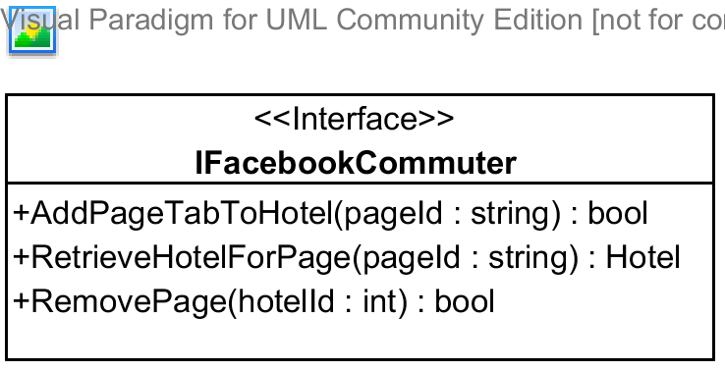

**Properties:** N/A

**Operations**

|  |  |  |
| --- | --- | --- |
| Signature: bool AddPageTabToHotel(string pageId, int hotelId)  Description: Adds a page tab to the hotel | | |
| Parameter | **Type** | **Description** |
| *pageId* | string | Id of the Facebook page to be added to the hotel |
| *hotelId* | int | Id of the hotel to be added |

|  |  |  |
| --- | --- | --- |
| Signature: Hotel RetrieveHotelForPage(string pageId)  Description: Retrieves a hotel given its pageId | | |
| Parameter | **Type** | **Description** |
| *pageId* | string | Facebook page id of the hotel to be retrieved |

|  |  |  |
| --- | --- | --- |
| Signature: bool RemovePage(int hotelId)  Description: Removes the Facebook page from the hotel given its id | | |
| Parameter | **Type** | **Description** |
| *hotelId* | int | Id of the hotel to remove the Facebook page |

#### IScheduling Interface

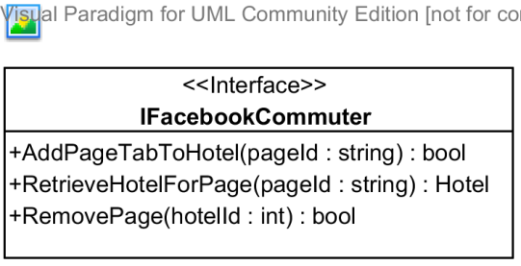

**Properties:** N/A

**Operations**

|  |  |  |
| --- | --- | --- |
| Signature: bool AddPageTabToHotel(string pageId, int hotelId)  Description: Adds a page tab to the hotel | | |
| Parameter | **Type** | **Description** |
| *pageId* | string | Id of the Facebook page to be added to the hotel |
| *hotelId* | int | Id of the hotel to be added |

|  |  |  |
| --- | --- | --- |
| Signature: Hotel RetrieveHotelForPage(string pageId)  Description: Retrieves a hotel given its pageId | | |
| Parameter | **Type** | **Description** |
| *pageId* | string | Facebook page id of the hotel to be retrieved |

|  |  |  |
| --- | --- | --- |
| Signature: bool RemovePage(int hotelId)  Description: Removes the Facebook page from the hotel given its id | | |
| Parameter | **Type** | **Description** |
| *hotelId* | int | Id of the hotel to remove the Facebook page |

## Behavioral Diagrams



### State Machine Diagram: Booking Status Transition

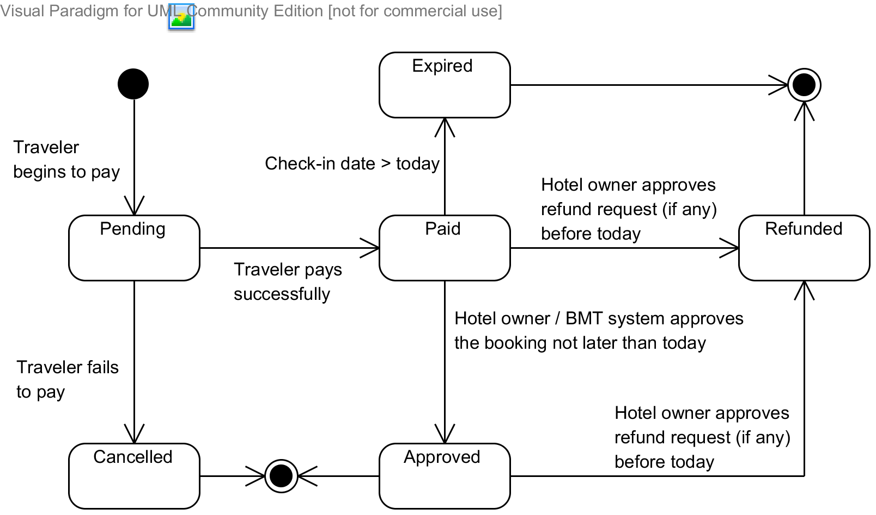

Diagram 2 State machine diagram: Booking status transition

### State Machine Diagram: Refund Request Status Transition

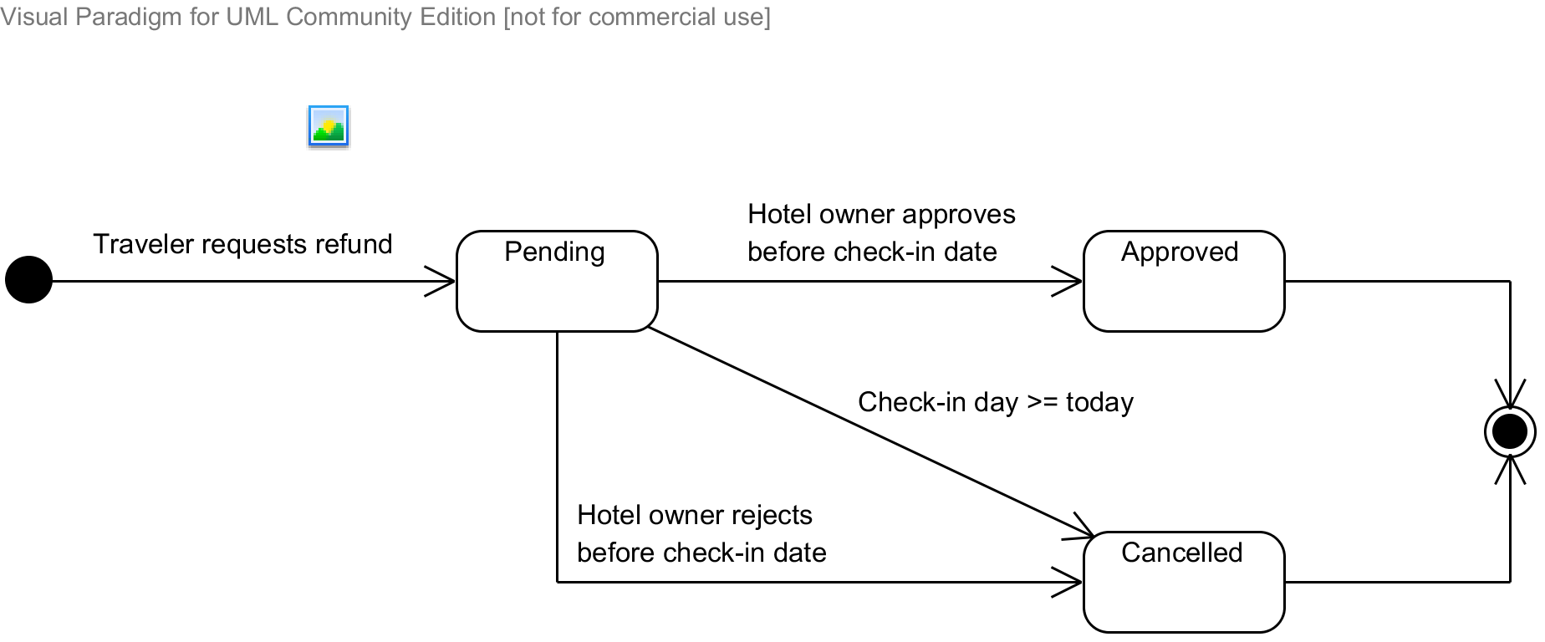

Diagram 3 State machine diagram: Refund request status transition

### Sequence Diagram: Search Hotels

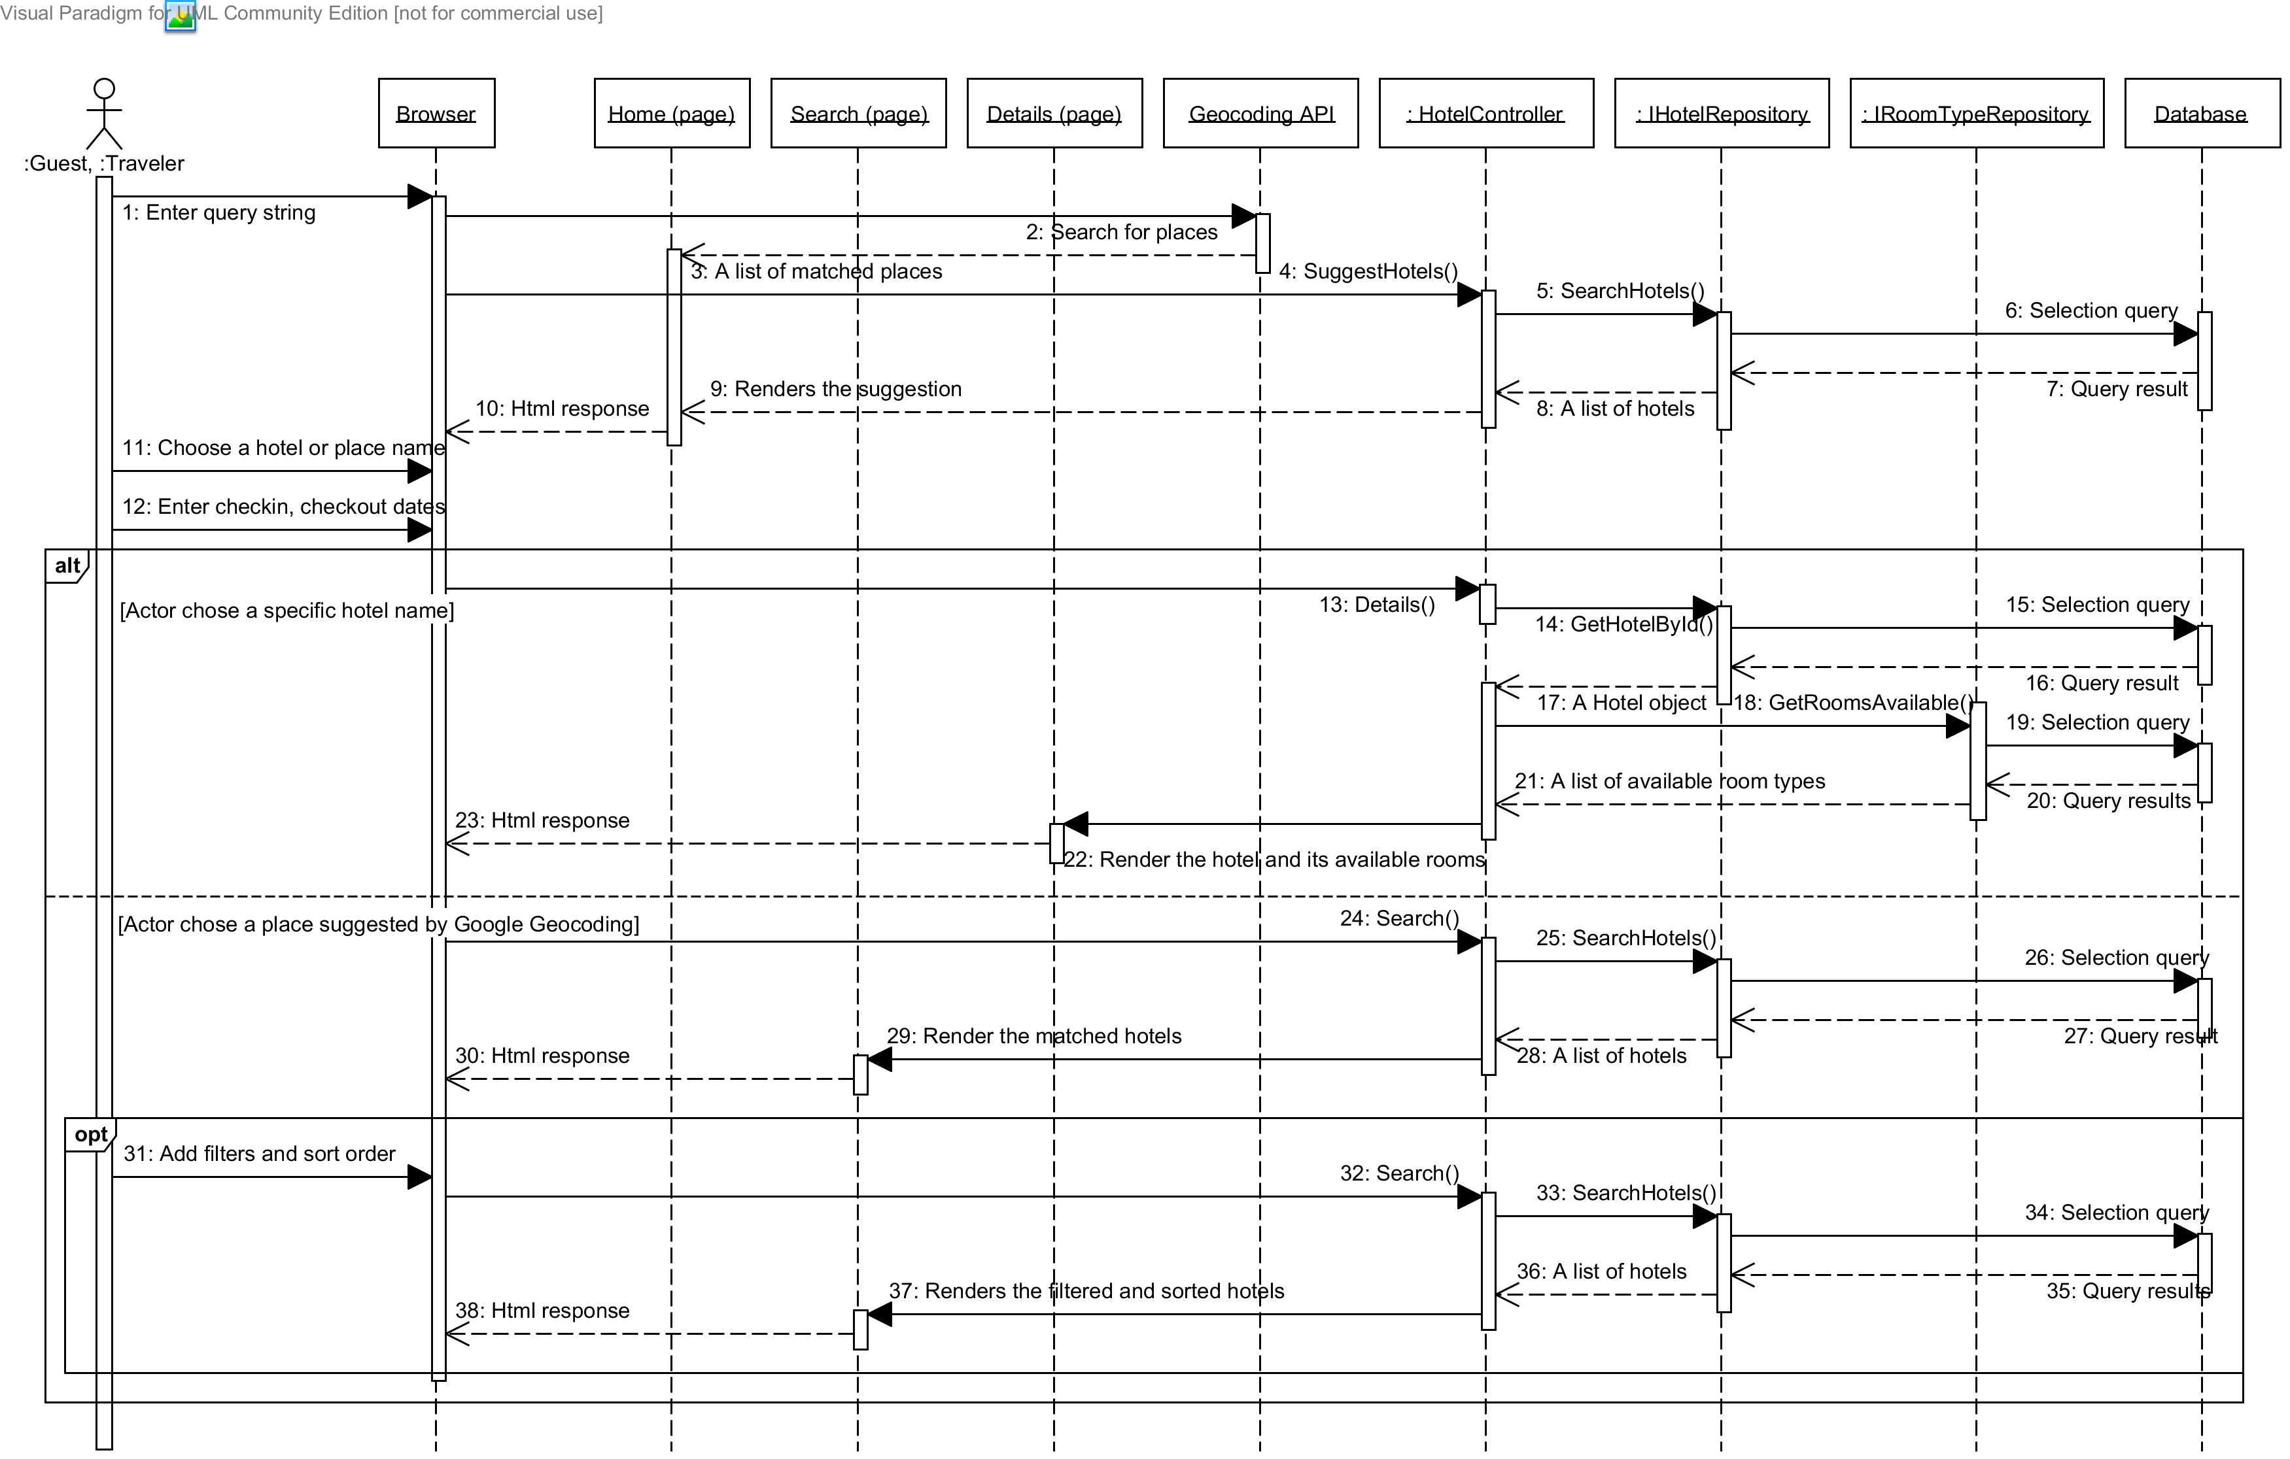

Diagram 4 Sequence diagram: Search Hotels

### Sequence Diagram: Add Rooms to Booking List

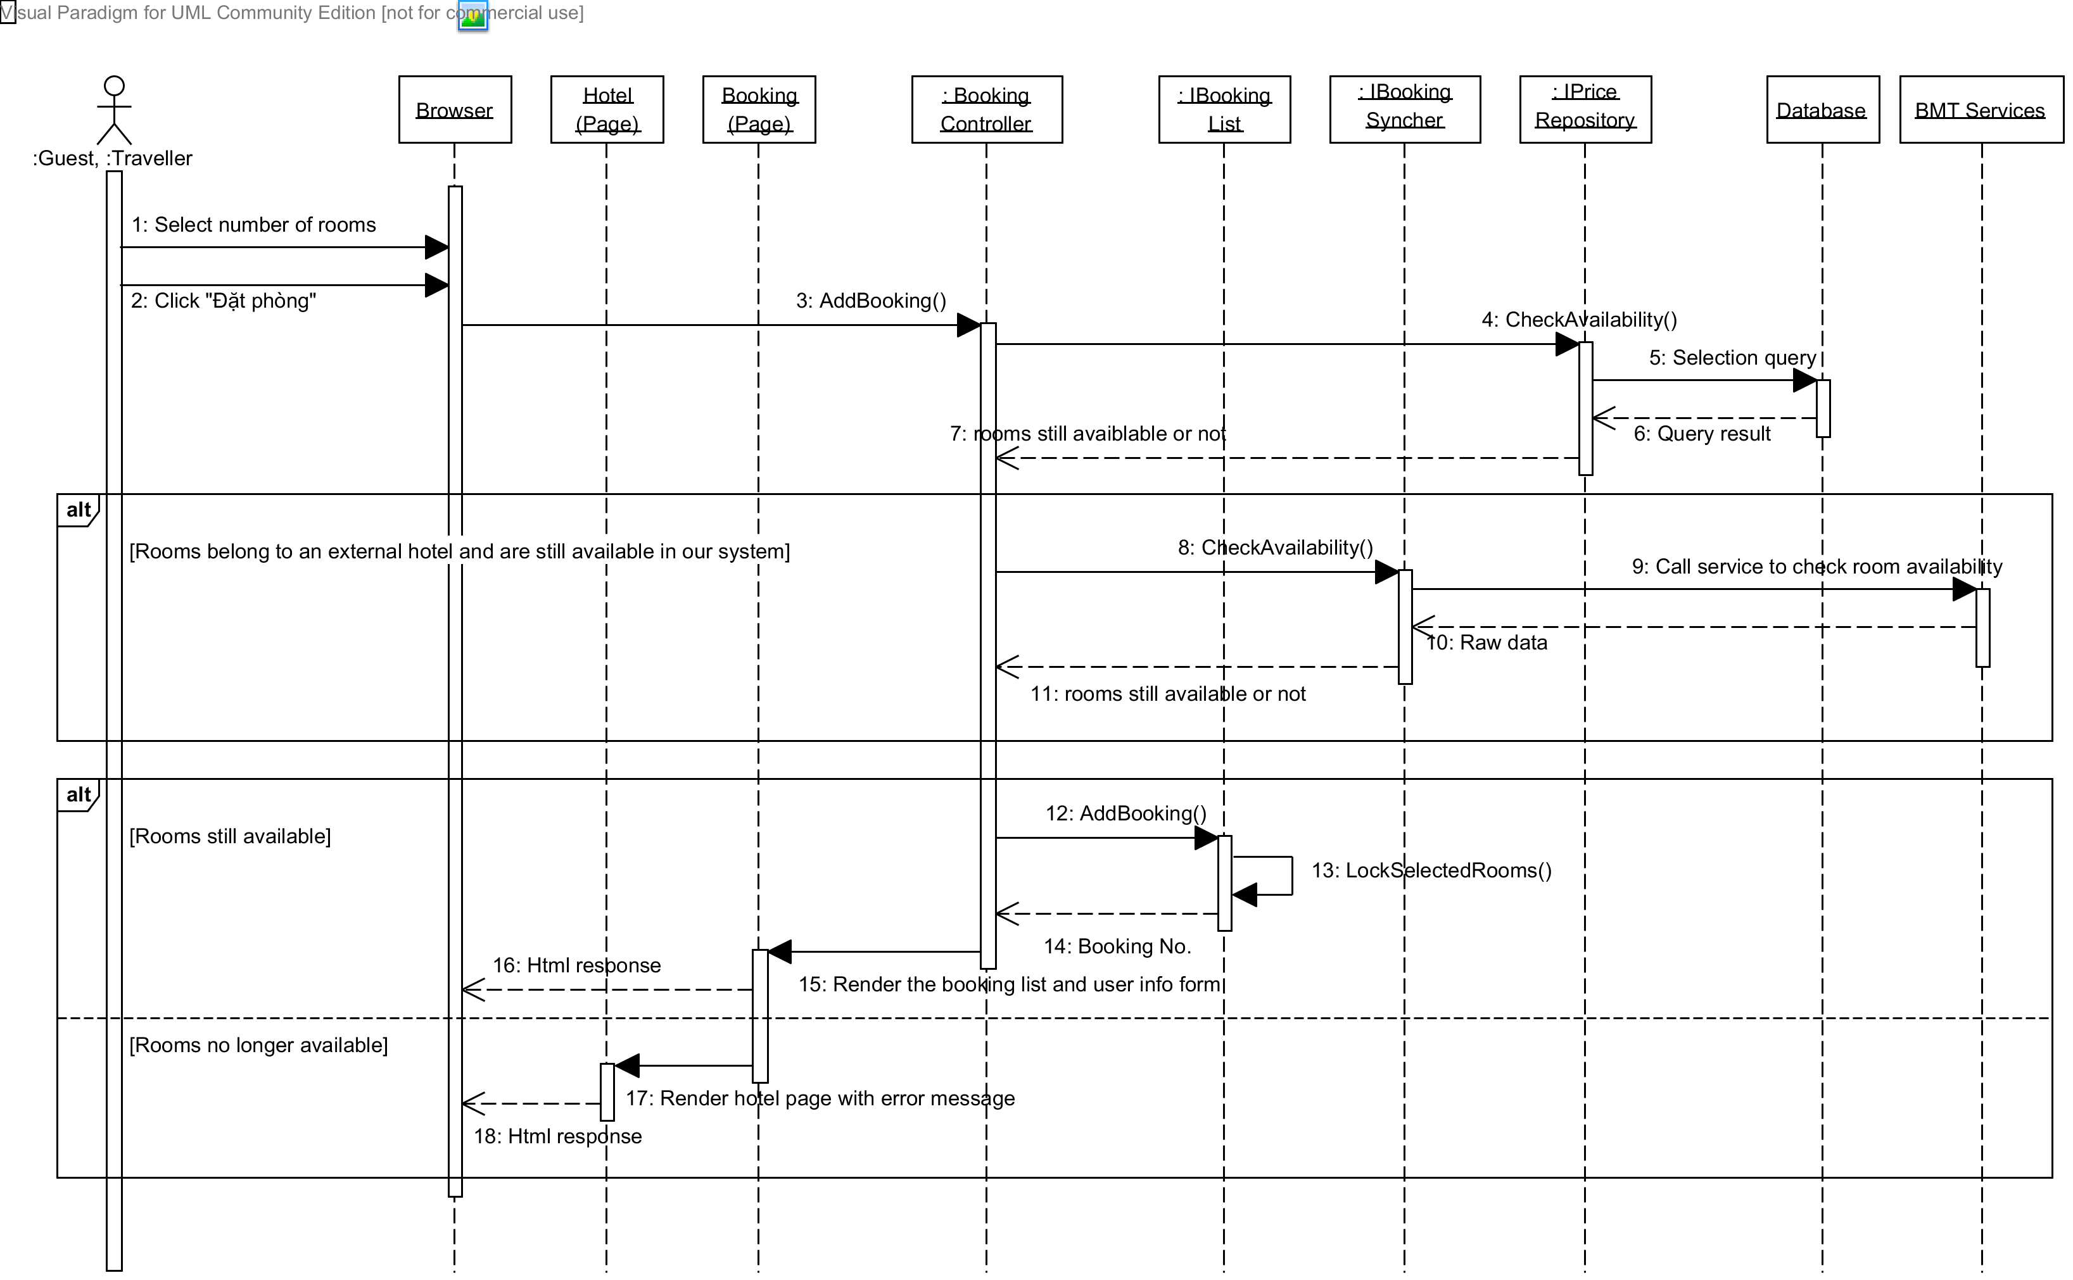

Diagram 5 Sequence diagram: Add rooms to booking list

### Sequence Diagram: Book Rooms and Pay

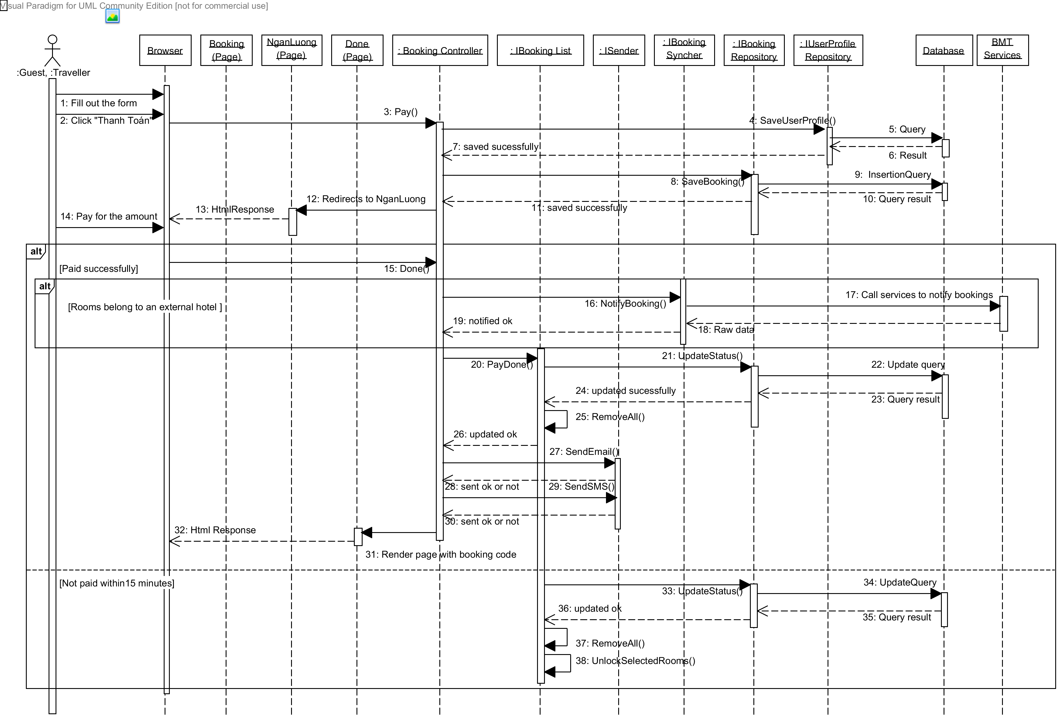

Diagram 6 Sequence diagram: Book rooms and pay

### Sequence Diagram: Request a Refund

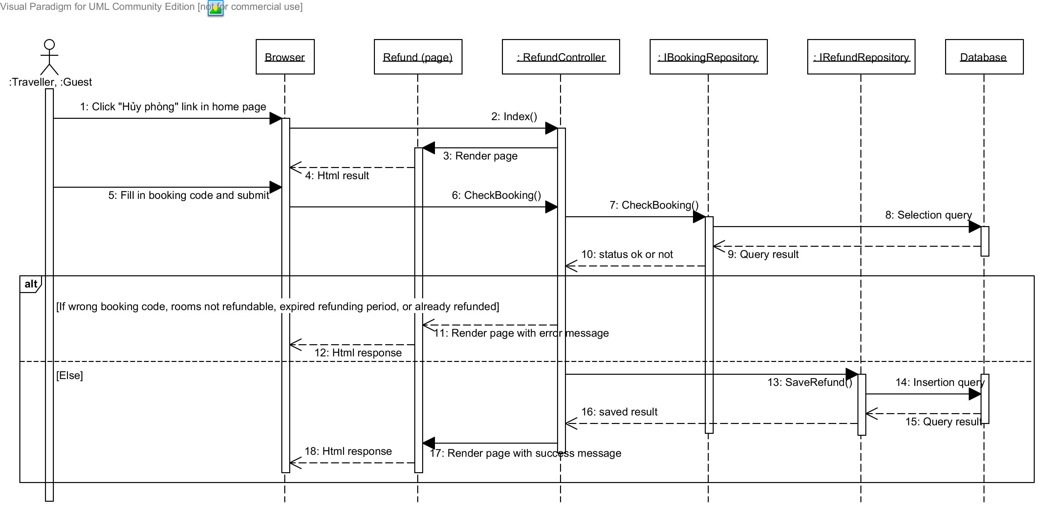

Diagram 7 Sequence diagram: Request a refund

### Sequence Diagram: Create a Hotel

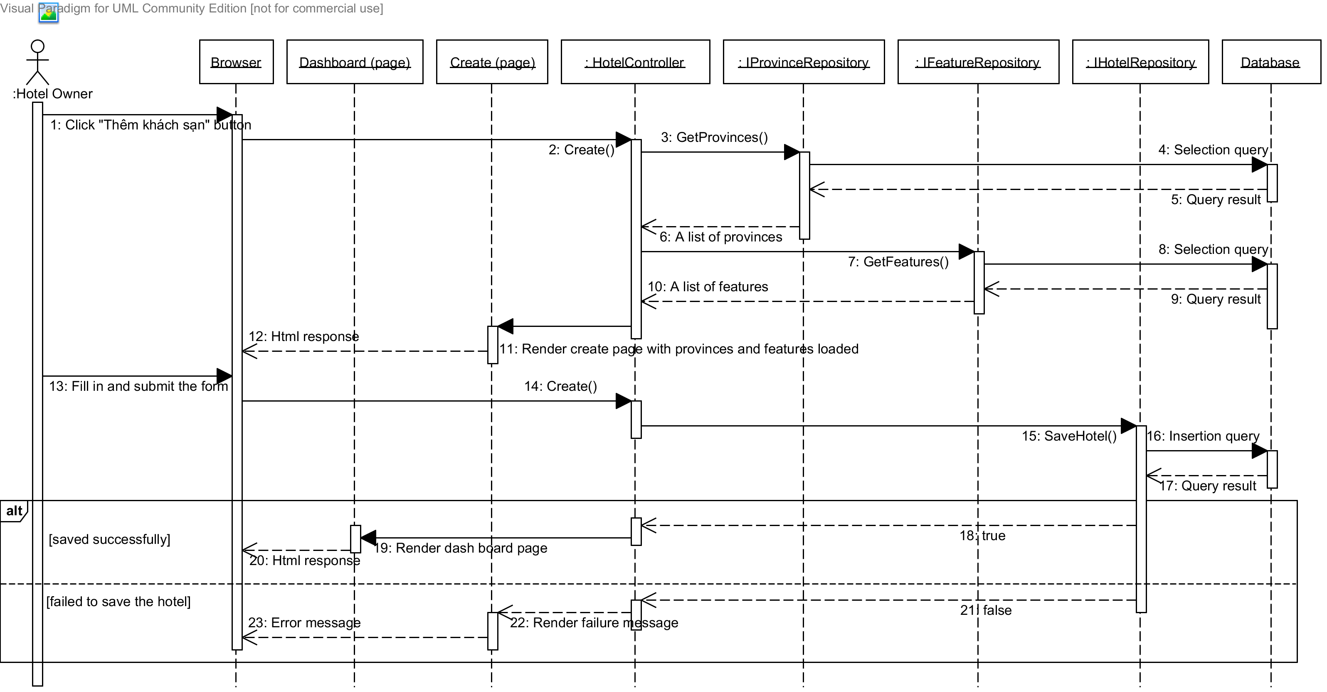

Diagram 8 Sequence diagram: Create a hotel

### Sequence Diagram: Edit a Hotel

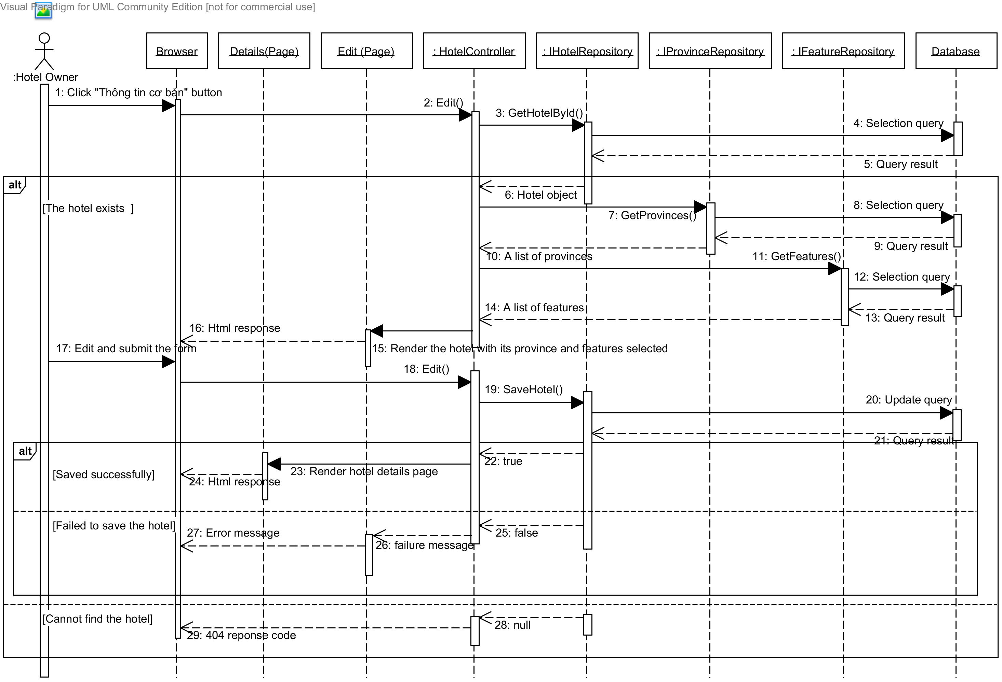

Diagram 13. Sequence diagram: Edit a hotel

### Sequence Diagram: Add a Price

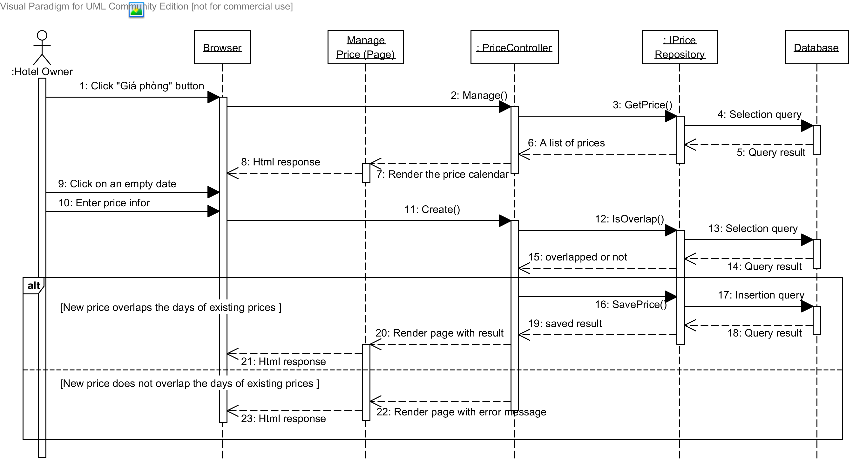

Diagram 10 Sequence diagram: Add a price

### Sequence Diagram: Approve a Booking

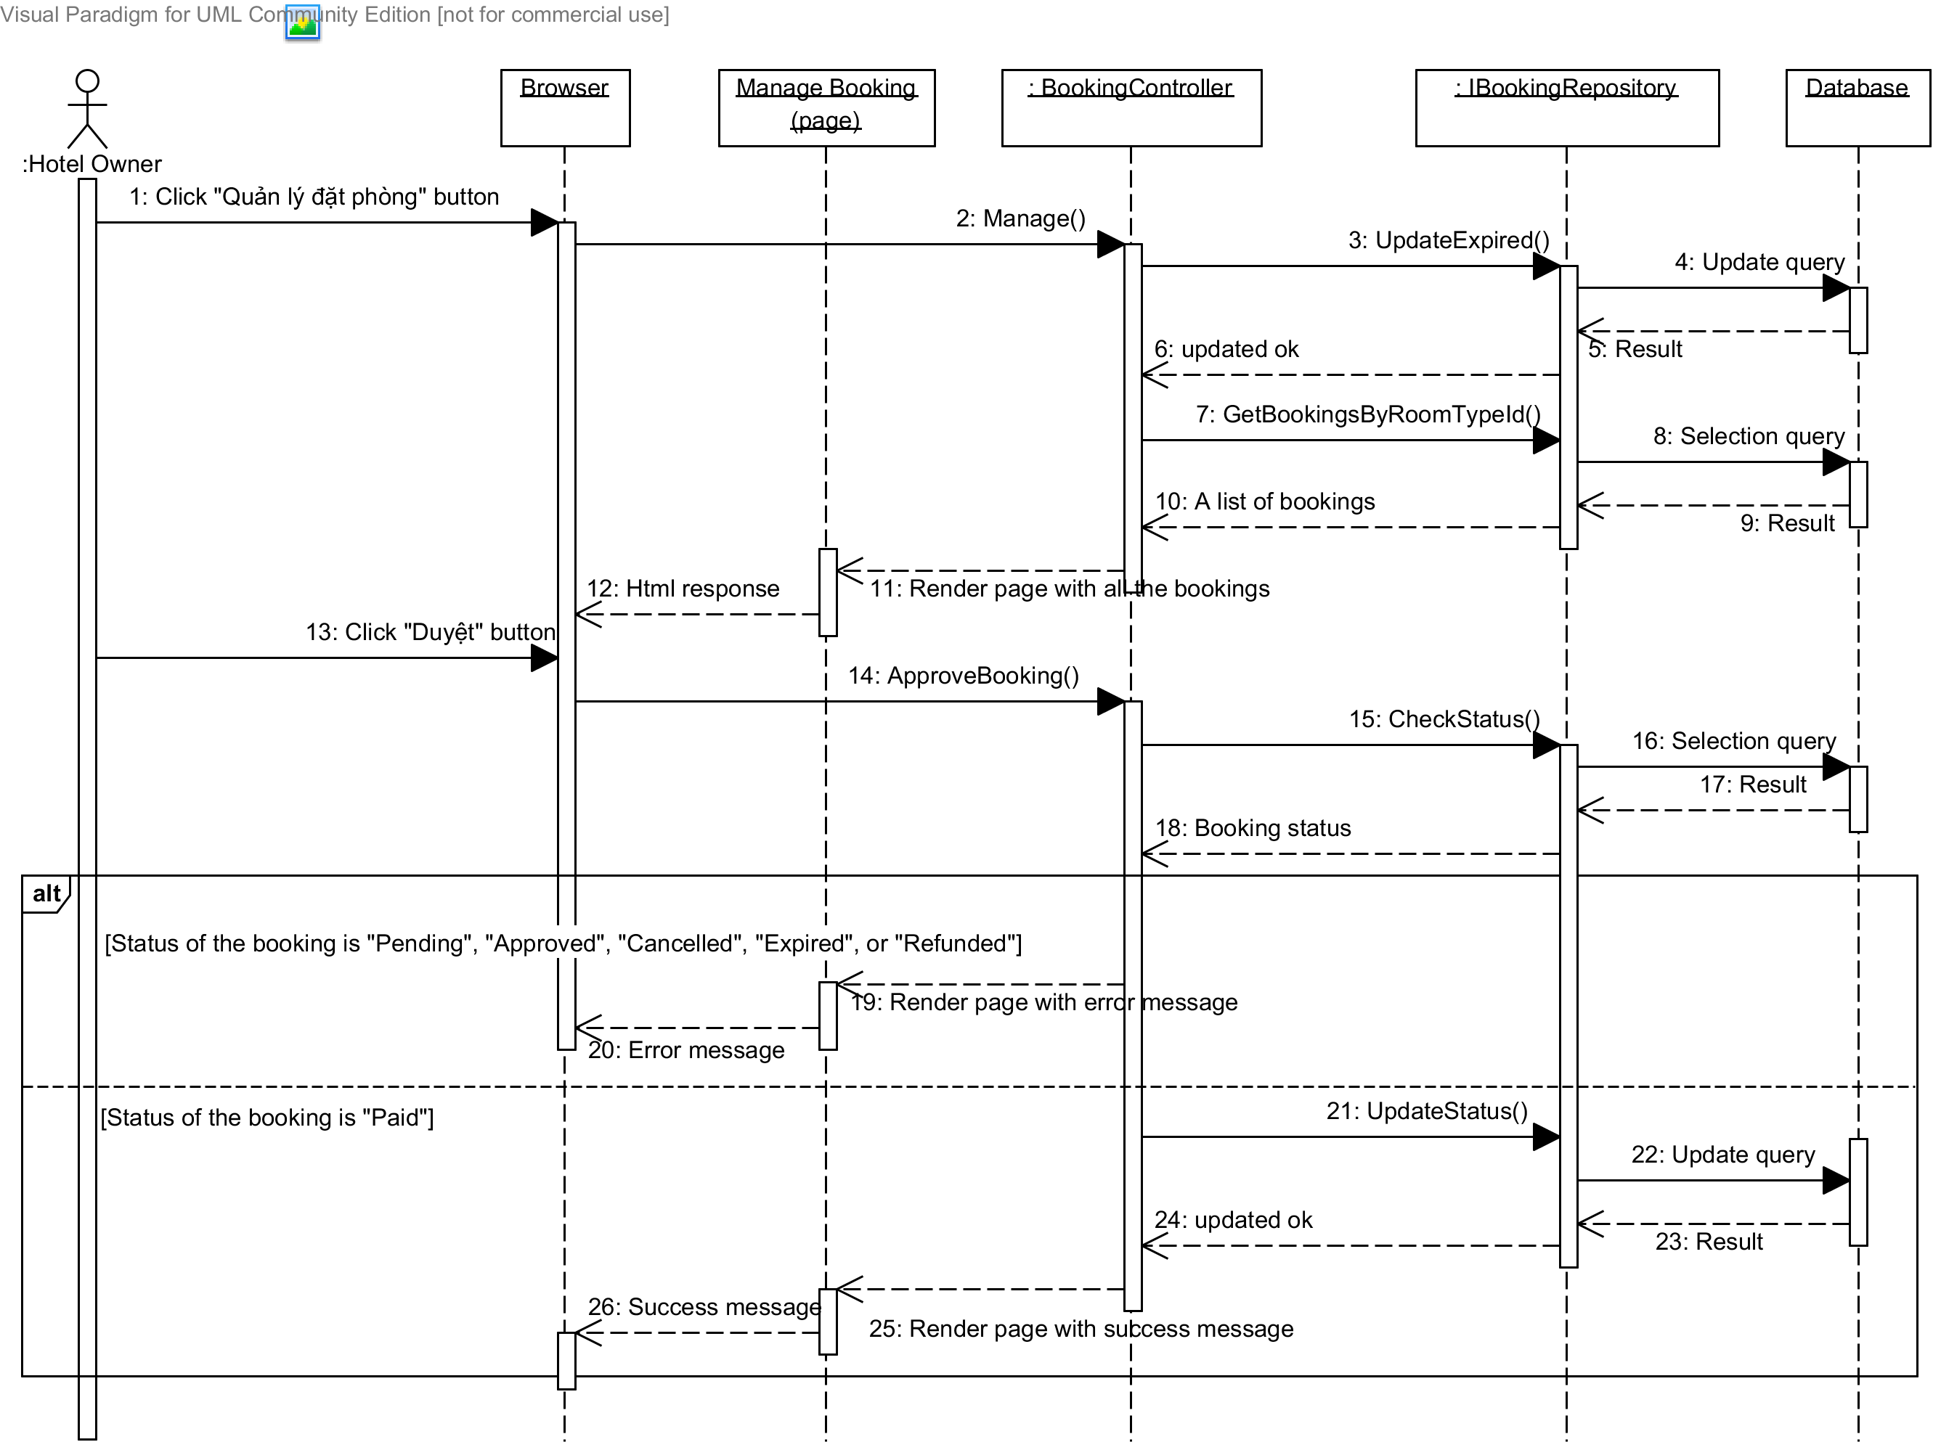

Diagram 15. Sequence diagram: Approve a booking

### Sequence Diagram: Approve a Refund Request

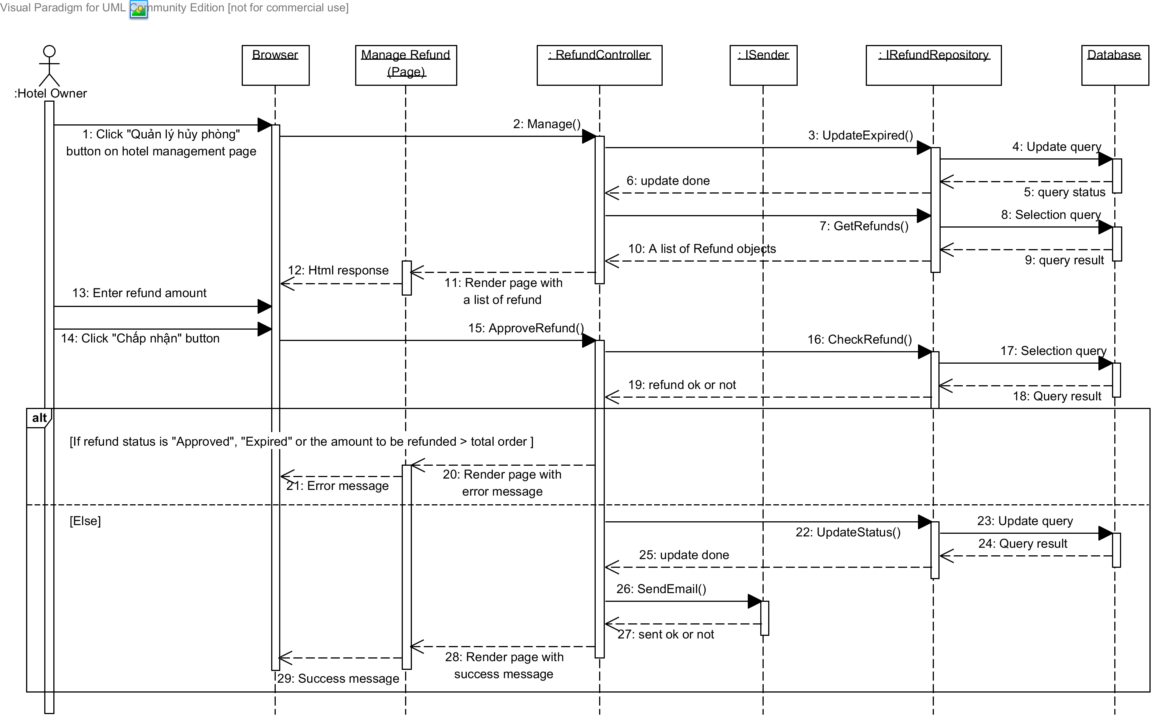

Diagram 16. Sequence diagram: Approve a refund request

### Sequence Diagram: Get Hotel Information from BMT

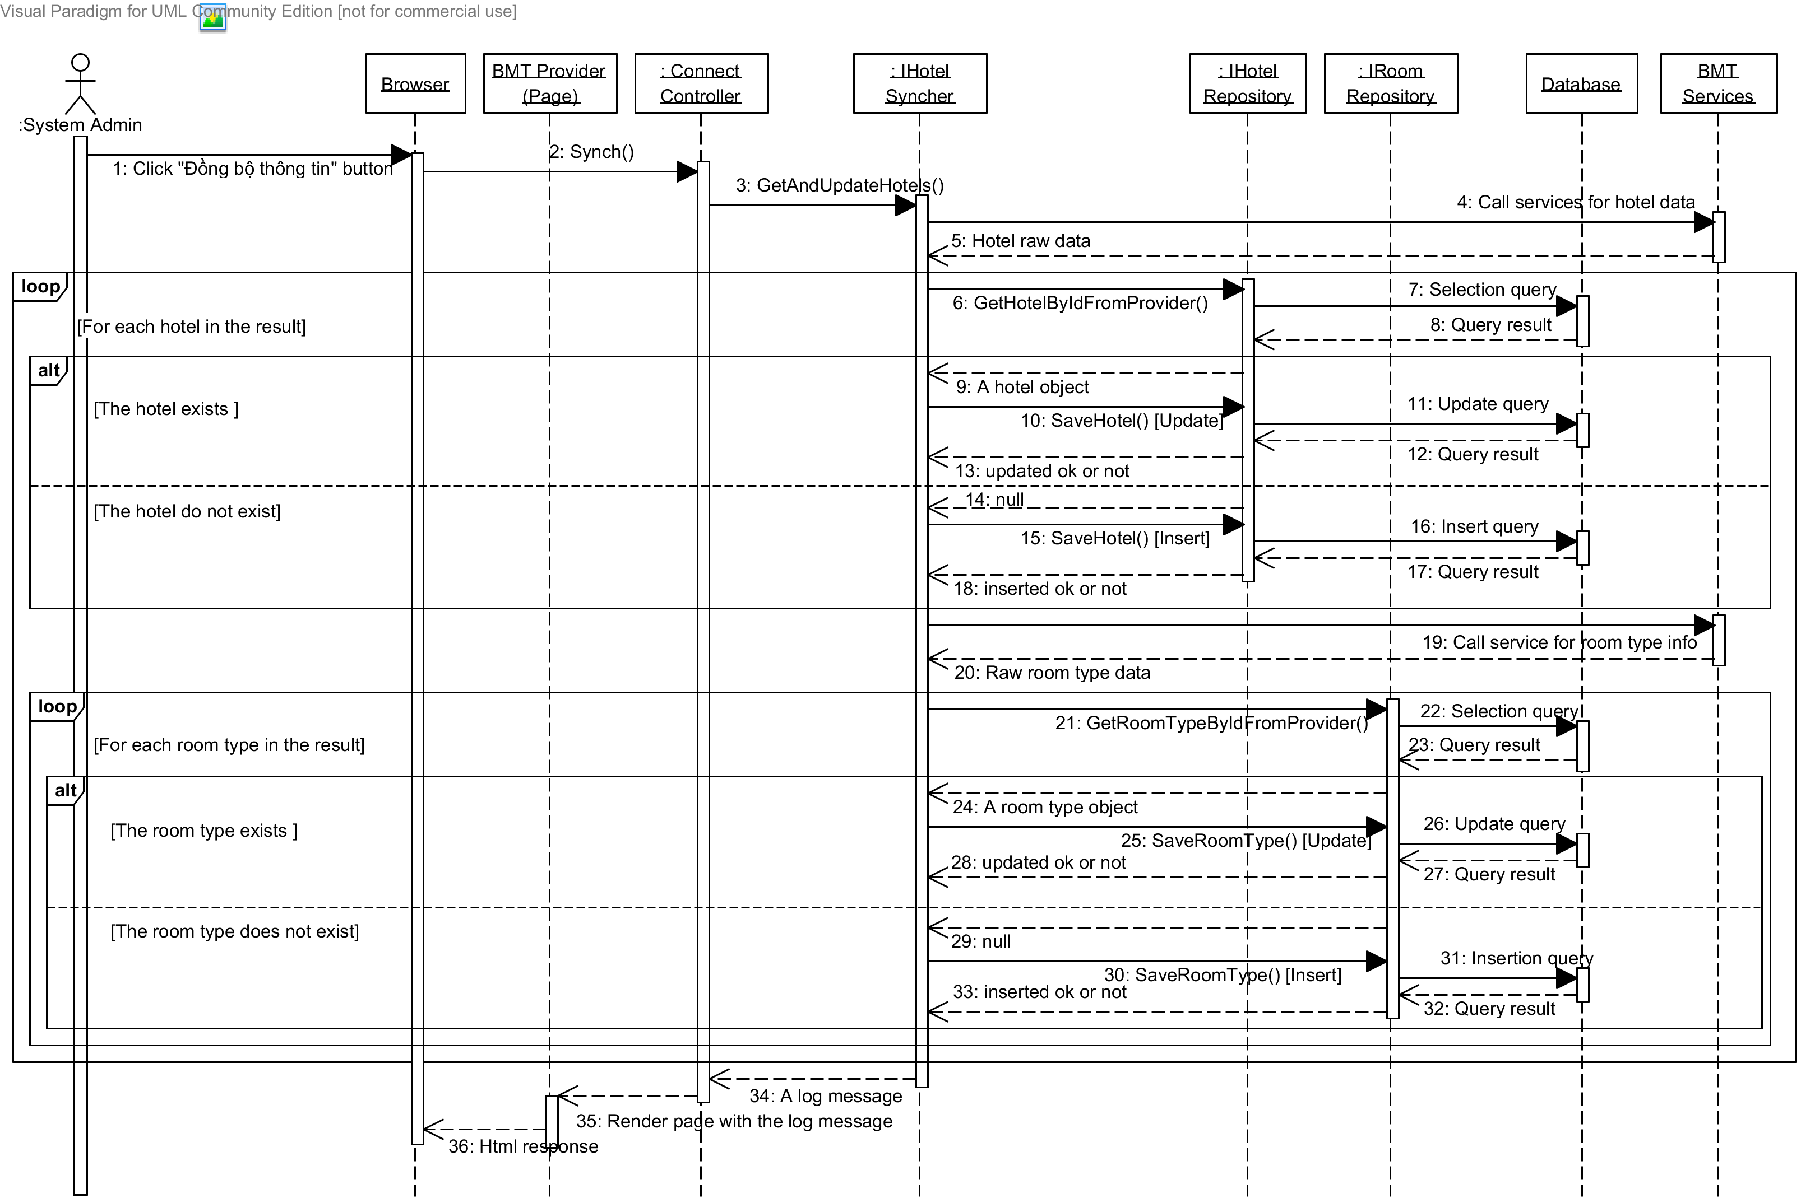

Diagram 17. Sequence diagram: Get hotel information from BMT

### Sequence Diagram: Get Prices from BMT

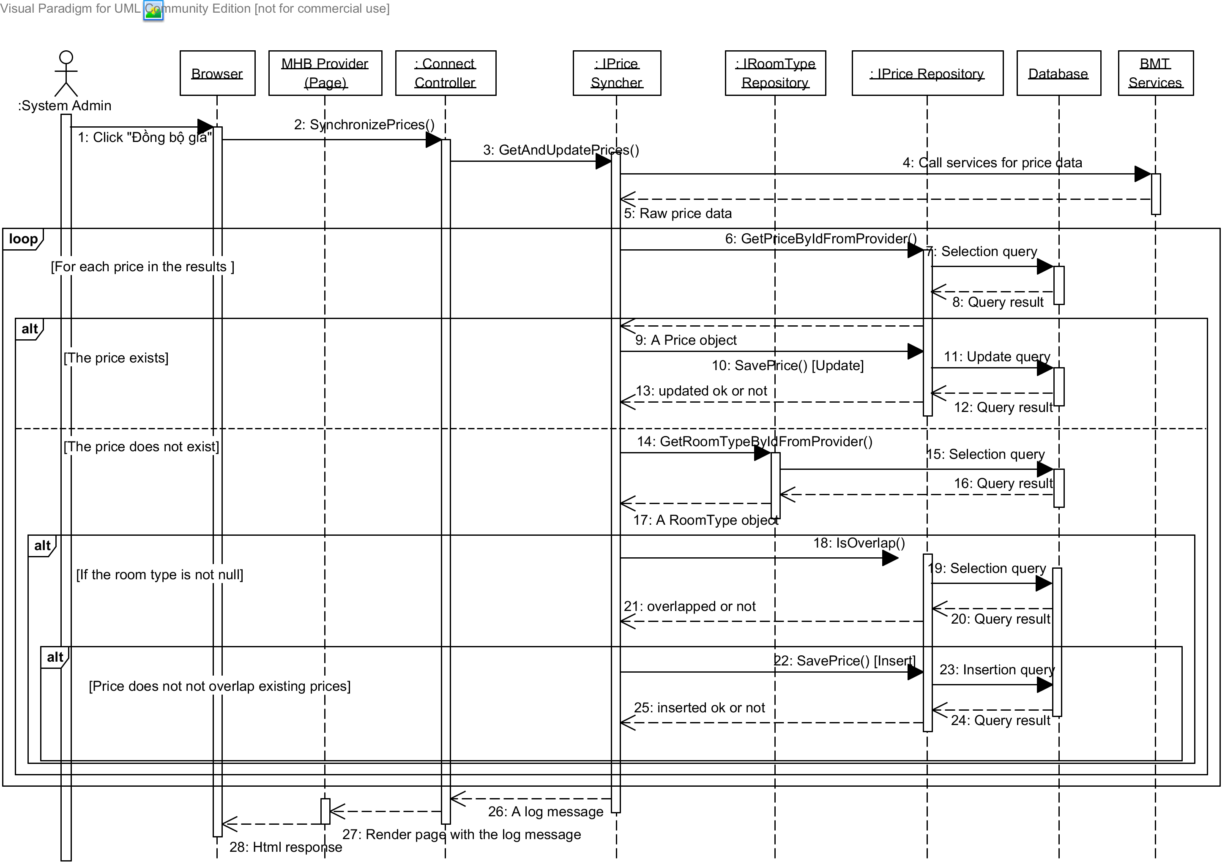

Diagram 18. Sequence diagram: Get prices from BMT

### Sequence Diagram: Install Facebook tab

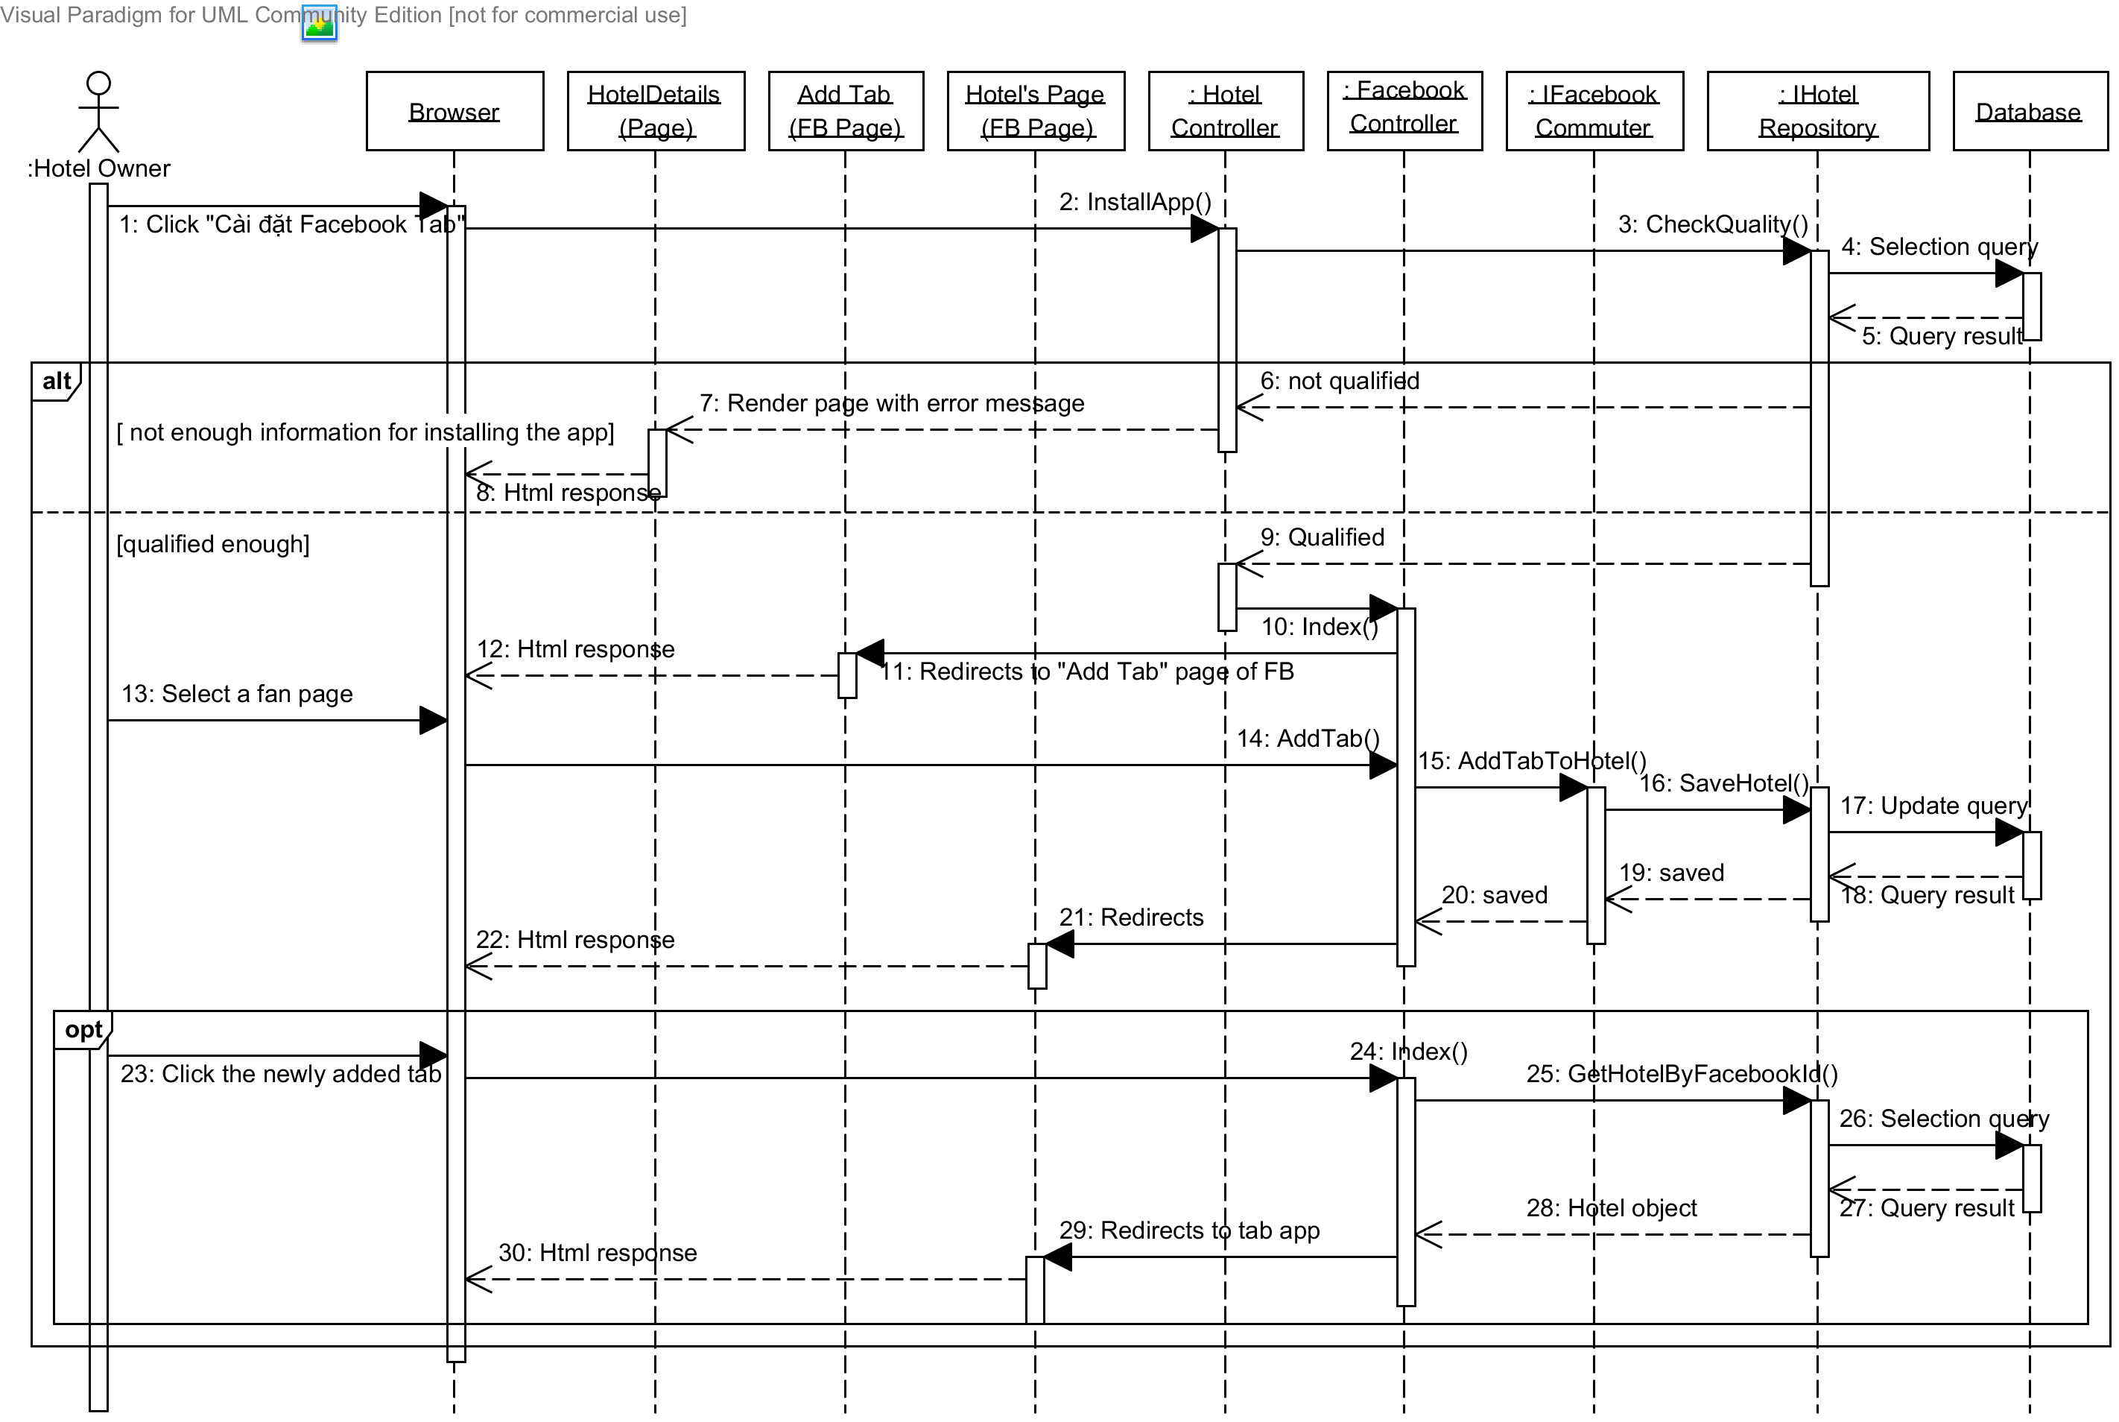

Diagram 19. Sequence diagram: Install Facebook tab

## User Interface Design

Below are some important screen designs for the MHB systems.



### Home Page

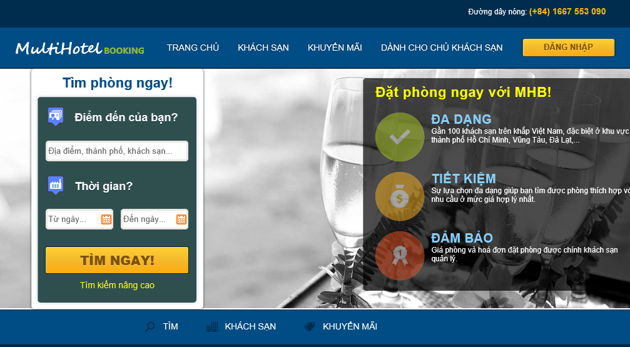

10

9

8

7

6

3

5

2

4

1

Figure 2 Home page

|  |  |  |  |  |  |  |
| --- | --- | --- | --- | --- | --- | --- |
| No. | Element | Description | Read Only | Mandatory | Control Type | Data type |
| 1. | “Trang chủ” link | A link to the home page of the hotel information portal | N/A | N/A | Link | N/A |
| 2. | “Khách sạn” link | A link to the hotel list page | N/A | N/A | Link | N/A |
| 3. | “Khuyến mãi” | A link to the promotion page for all hotels | N/A | N/A | Link | N/A |
| 4. | “Dành cho chủ khách sạn”link | A link to the page for hotel owners | N/A | N/A | Link | N/A |
| 5. | “Đăng nhập” button | A button that displays the log in popup | N/A | N/A | Button | N/A |
| 6. | “Điểm đến” textbox | The place where the traveler wish to go to | No | Yes | Textbox | Text |
| 7. | “Từ ngày” texbox | The date when the traveler wants to check in | No | Yes | Textbox | Text |
| 8. | “Đến ngày” textbox | The date when the traveler wants to check out | No | Yes | Textbox | Text |
| 9. | “Tìm ngay” textbox | A button that leads to the search results page | N/A | N/A | Button | N/A |
| 10. | “Tìm kiếm nâng cao” button | A link to the advanced search page | N/A | N/A | Link | N/A |

### Search Hotels Page

|  |  |  |  |  |  |  |
| --- | --- | --- | --- | --- | --- | --- |
| No. | Element | Description | Read Only | Mandatory | Control Type | Data type |
| 1. | “Điểm đến” textbox | The place where the traveler wishes to go to | No | Yes | Textbox | Text |
| 2. | “Từ ngày” textbox | The date when the traveler wants to check in | No | Yes | Textbox | Text |
| 3. | “Đến ngày” textbox | The date when the traveler wants to check out | No | Yes | Textbox | Text |
| 4. | “Chọn thứ tự” dropdown list | The order of the results | No | No | Dropdown list | N/A |
| 5. | “Bán kính” dropdown list | The radius from the center of the destination | No | No | Button | N/A |
| 6. | “Tìm kiếm” button | A button that searches and displays hotels | N/A | N/A | Button | N/A |
| 7. | “Tỉnh, thành phố” checkboxes | A groups of provinces to filter the results | No | No | Check-boxes | Text |
| 8. | “Tiêu chuẩn khách sạn” checkboxes | A groups of star qualities to filter the results | No | No | Check-boxes | Text |
| 9. | “Đánh giá” checkboxes | A group of user rating averages to filter the results | No | No | Check-boxes | Text |
| 10. | “Lọc kết quả” button | A button that filters the results found | N/A | N/A | Link | N/A |
| 11. | Details of a hotel section | Detailed information of a hotel | N/A | N/A | Div | N/A |
| 12. | Price of a hotel section | Lowest price for a hotel. | N/A | N/A | Div | N/A |
| 13. | Google map section | A Google map that displays all the hotels found | N/A | N/A | Map | N/A |
| 14. | Marker for a destination | A Google marker for the destination the user searches | N/A | N/A | Marker | N/A |
| 15. | Marker for a hotel | A Google marker for a hotel in the result | N/A | N/A | Marker | N/A |

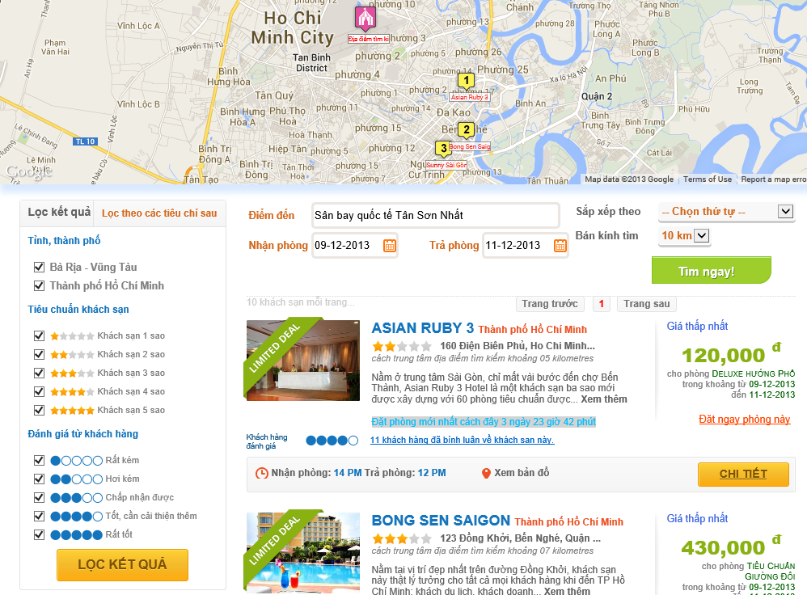

15

14

13

12

11

10

1

4

5

6

9

8

7

3

2

Figure 3 Search Hotel page

### Hotel Details Page

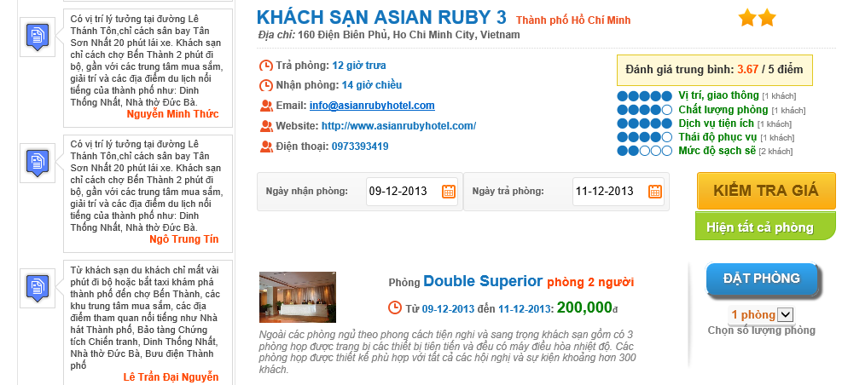

2

11

10

6

5

9

71

8

4

3

1

Figure 4 Hotel Details page

|  |  |  |  |  |  |  |
| --- | --- | --- | --- | --- | --- | --- |
| No. | Element | Description | Read Only | Mandatory | Control Type | Data type |
| 1. | Details of a hotel section | Detailed information of a hotel | N/A | N/A | Div | N/A |
| 2. | Rating average points section | Rating average points rated by traveler. | N/A | N/A | Div | N/A |
| 3. | “Ngày nhận phòng” textbox | The date when the traveler wants to check in | No | Yes | Textbox | Text |
| 4. | “Ngày trả phòng” textbox | The date when the traveler wants to check out | No | Yes | Textbox | Text |
| 5. | “Kiểm tra giá” button | A button that searches and displays room types available | N/A | N/A | Button | N/A |
| 6. | “Hiện tất cả phòng” button | A button that displays all room types of a hotel | N/A | N/A | Button | N/A |
| 7. | Details of a room type section | Detailed information of a room type | N/A | N/A | Div | N/A |
| 8. | Price section | Price for a room in the searching period. If there are many prices for this period, all of them are displayed. | N/A | N/A | Div | N/A |
| 9. | “Đặt phòng” button | A button that leads to the Booking Details page | N/A | N/A | Button | N/A |
| 10. | “Số lượng phòng” dropdown list | The number of rooms the traveler wants to book | No | No | Dropdown list | Text |
| 11. | Review section | A review for the hotel | N/A | N/A | Div | N/A |

### Booking Details Page

|  |  |  |  |  |  |  |
| --- | --- | --- | --- | --- | --- | --- |
| No. | Element | Description | Read Only | Mandatory | Control Type | Data type |
| 1. | “Giới tính” dropdown list | Gender of the traveler | No | Yes | Textbox | Text |
| 2. | “Họ và tên” textbox | Full name of the traveler | No | Yes | Textbox | Text |
| 3. | “Địa chỉ” textbox | Address line of the traveler | No | Yes | Textbox | Text |
| 4. | “Ngày tháng năm sinh” textbox | Date of birth of the traveler |  | Yes | Textbox | Text |
| 5. | “Email” textbox | Email address of the traveler | No | Yes | Textbox | Text |
| 6. | “Số điện thoại” textbox | Telephone number of the traveler | No | Yes | Textbox | Text |
| 7. | “Yêu cầu” text area | Any custom request the traveler want to send to the hotel | No | No | Text area | Text |
| 8. | “Đặt thêm phòng” link | A link to go back to the hotel to book more rooms | N/A | N/A | Link | N/A |
| 9. | “Chi tiết đặt phòng” section | The booking detail of the rooms booked | N/A | N/A | Div | N/A |
| 10. | Details button | A button that displays the price details of a booking when it is hovered | N/A | N/A | Button | N/A |
| 11. | Edit booking button | A button to edit the current booking | N/A | N/A | Button | N/A |
| 12. | Delete booking button | A button to remove the current booking | N/A | N/A | Button | N/A |
| 13. | “Thanh toán” section | The detail of total amount | N/A | N/A | Div | N/A |
| 14. | “Thanh toán” button | A button that leads to the payment page | N/A | N/A | Button | N/A |

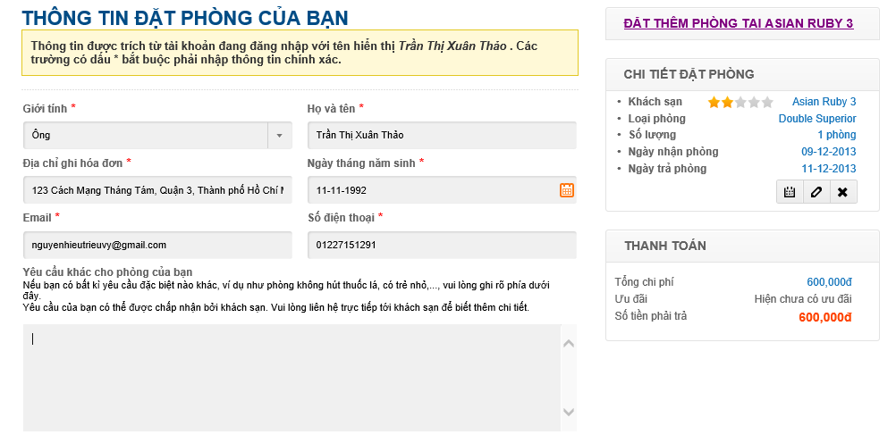

8

14

13

12

11

10

9

7

6

5

4

3

1

2

Figure 5 Booking Details page

### Booking Success Page

|  |  |  |  |  |  |  |
| --- | --- | --- | --- | --- | --- | --- |
| No. | Element | Description | Read Only | Mandatory | Control Type | Data type |
| 1. | Payment information section | The details of the payment made by the customer | N/A | N/A | Div | N/A |
| 2. | Booking code | The booking code generated for the booking made | N/A | N/A | Div | N/A |
| 3. | Customer information | The detailed information of the customer who made the booking | N/A | N/A | Div | N/A |
| 4. | Details of bookings | The details of the booking made by the customer | N/A | N/A | Div | N/A |

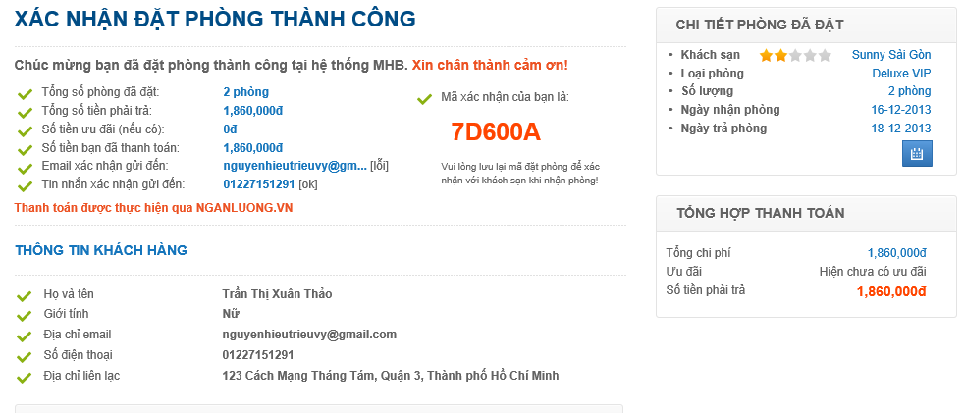

4

3

2

1

### Dashboard Page

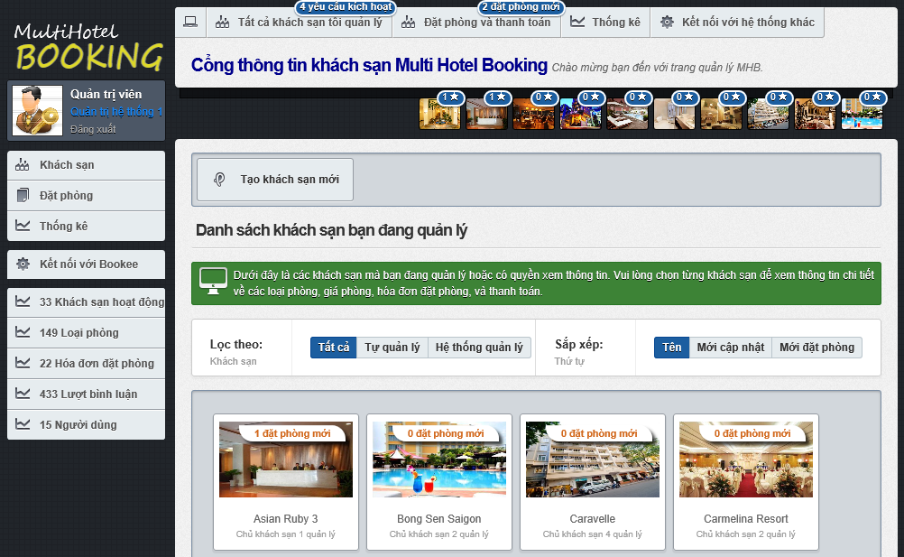

17

16

15

14

13

12

11

10

9

8

7

6

5

4

3

2

1

Figure 6 Dashboard page

|  |  |  |  |  |  |  |
| --- | --- | --- | --- | --- | --- | --- |
| No. | Element | Description | Read Only | Mandatory | Control Type | Data type |
| 1. | User information section | Information of the logged user | N/A | N/A | Div | N/A |
| 2. | “Khách sạn” link | A link to the dashboard page | N/A | N/A | Link | N/A |
| 3. | “Đặt phòng” link | A link to the booking manangement page | N/A | N/A | Link | N/A |
| 4. | “Thống kê” link | A link to the statistics page | N/A | N/A | Link | N/A |
| 5. | “Kết nối tới Bookee” link | A link to the data synchronization page | N/A | N/A | Link | N/A |
| 6. | New hotel opening requests notification | A notification for new hotel opening request issued by hotel owner | N/A | N/A | Div | N/A |
| 7. | New bookings notification | A notification for new bookings in all the hotels | N/A | N/A | Div | N/A |
| 8. | New bookings notification for a hotel | A notification for new bookings in a specific hotel | N/A | N/A | Div | N/A |
| 9. | “Tất cả” button | A button to list all the hotels | N/A | N/A | Button | N/A |
| 10. | “Tự quản lý” button | A button to filter on local hotels | N/A | N/A | Button | N/A |
| 11. | “MHB quản lý” button | A button to filter on external hotels | N/A | N/A | Button | N/A |
| 12. | “Tên” button | A button to sort the hotels by their names | N/A | N/A | Button | N/A |
| 13. | “Mới cập nhật” button | A button to sort the hotels by their last modified time | N/A | N/A | Button | N/A |
| 14. | “Mới đặt phòng” button | A button to sort the hotels by their last booked time | N/A | N/A | Button | N/A |
| 15. | Hotel list section | A list of all the hotels | N/A | N/A | Div | N/A |
| 16. | “Tạo khách sạn mới” button | A button that redirects to the hotel creating page | N/A | N/A | Button | N/A |
| 17. | Newly booked hotels section | A list of 10 hotel that have the most new bookings. | N/A | N/A | Div | N/A |

### Hotel Management Page

|  |  |  |  |  |  |  |
| --- | --- | --- | --- | --- | --- | --- |
| No. | Element | Description | Read Only | Mandatory | Control Type | Data type |
| 1. | “Kích hoạt khách sạn” button | A button used to activate a hotel opening request | N/A | N/A | Button | N/A |
| 2. | “Quay về trang quản lý khách sạn chung” button | A link to the dashboard page | N/A | N/A | Button | N/A |
| 3. | Name of the hotel | Name of the hotel you are viewing | N/A | N/A | Label | N/A |
| 4. | Information section | Detailed information of the hotel being viewed | N/A | N/A | Div | N/A |
| 5. | Completeness measure | Percent of information completeness for the hotel | N/A | N/A | Div | N/A |
| 6. | “Thông tin cơ bản” button | A link to the hotel editing page | N/A | N/A | Button | N/A |
| 7. | “Hình ảnh và thông tin nâng cao” button | A link to the hotel resouces page | N/A | N/A | Button | N/A |
| 8. | “Quản lý đặt phòng” button | A link to the booking management page | N/A | N/A | Button | N/A |
| 9. | “Đánh giá của người dùng” button | A link to the review management page | N/A | N/A | Button | N/A |

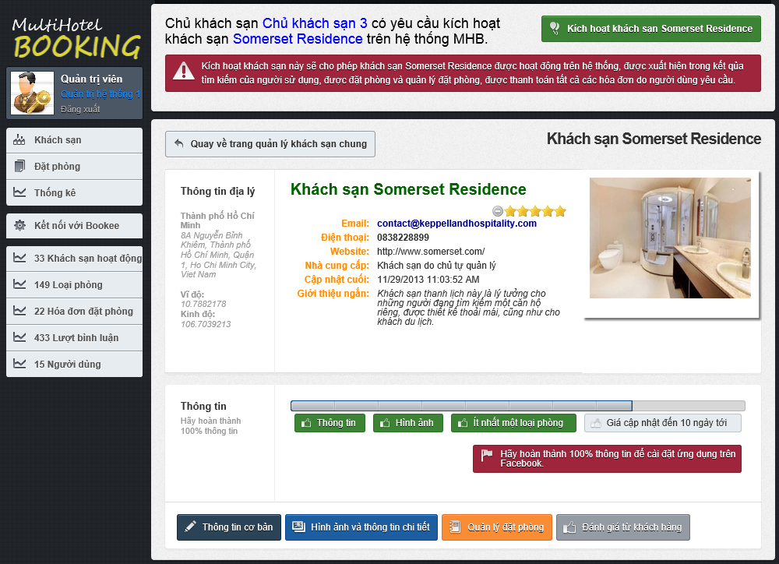

9

8

7

6

5

4

3

2

1

### Approve Booking Page

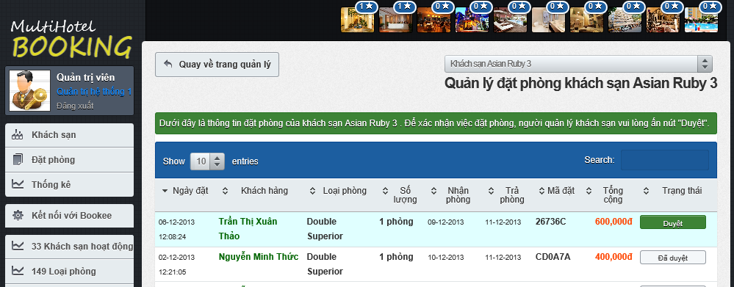

3

2

1

Figure 7 Approve Booking page

|  |  |  |  |  |  |  |
| --- | --- | --- | --- | --- | --- | --- |
| No. | Element | Description | Read Only | Mandatory | Control Type | Data type |
| 1. | Booking detail row | Details of a booking | N/A | N/A | Row | N/A |
| 2. | “Duyệt” link | A button to approve of a booking made by a traveler | N/A | N/A | Button | N/A |
| 3. | “Đã duyệt” link | A disabled button that indicates that the booking was approved sucessfully | Yes | N/A | Button | N/A |

### Prices Monitor Page

|  |  |  |  |  |  |  |
| --- | --- | --- | --- | --- | --- | --- |
| No. | Element | Description | Read Only | Mandatory | Control Type | Data type |
| 1. | Gray price bar | A price bar (in gray) that represents a price in the past. | N/A | N/A | Div | N/A |
| 2. | Violet price bar | A price bar (in violet) that represents a price crossing from the past to the future (including the current system date). | N/A | N/A | Div | N/A |
| 3. | Blue price bar | A price bar (in blue) that represents a price in the future. | N/A | N/A | Div | N/A |
| 4. | Red bar | The number of bookings made on a specific day for the selected room type. | N/A | N/A | Div | N/A |

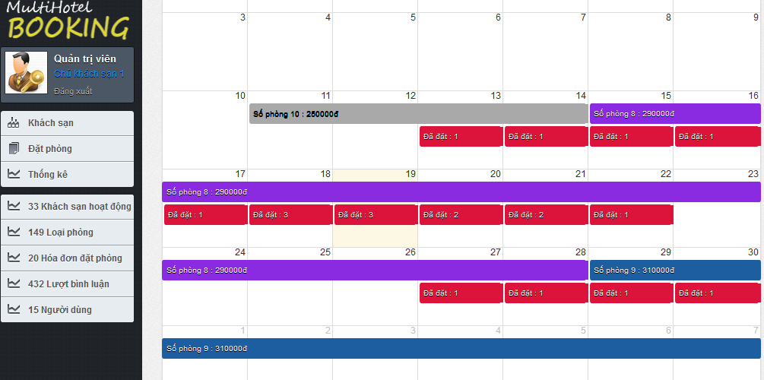

1

3

2

4

## Database Design



### Logical database design

From the ERD specified in the SRS section, logical database design includes the following relations:

|  |  |  |
| --- | --- | --- |
| No. | Relation | Description |
| 1. | Province | Stores all the provinces in Vietnam. |
| 2. | Provider | Stores information of hotel data providers. |
| 3. | Hotel | Stores information of local and external hotels in the MHB system. |
| 4. | Feature | Stores features that can be can be used to describe hotels. |
| 5. | HotelFeature | Stores the specific features associated with the hotels. |
| 6. | Image | Stores all hotel images. |
| 7. | RoomType | Stores all room types of all the hotels in the MHB system. |
| 8. | Price | Stores prices for all the room types of all the hotels. |
| 9. | DailyStatus | Stores the daily available statuses of all the prices. |
| 10. | Booking | Stores all the bookings made by the users of the system. |
| 11. | BookingItem | Stores details of all the bookings. |
| 12. | Refund | Stores all the refunds requested by the users who have booked rooms. |
| 13. | Review | Stores all the review written by the users of the system. |
| 14. | Rating | Stores all the ratings for hotels made by the users of the system. |
| 15 | RatingCriterion | Stores all the criteria which the users of the system can rate. |
| 16. | UserProfile | Stores information of all the users in the system. |
| 17. | Role | Stores all the roles used to grant access rights to users. |
| 18. | AdminHotel | Stores all the hotels under the management of the users. |
| 19. | UserRole | Stores the roles that users are granted |



The details of each relation are specified below

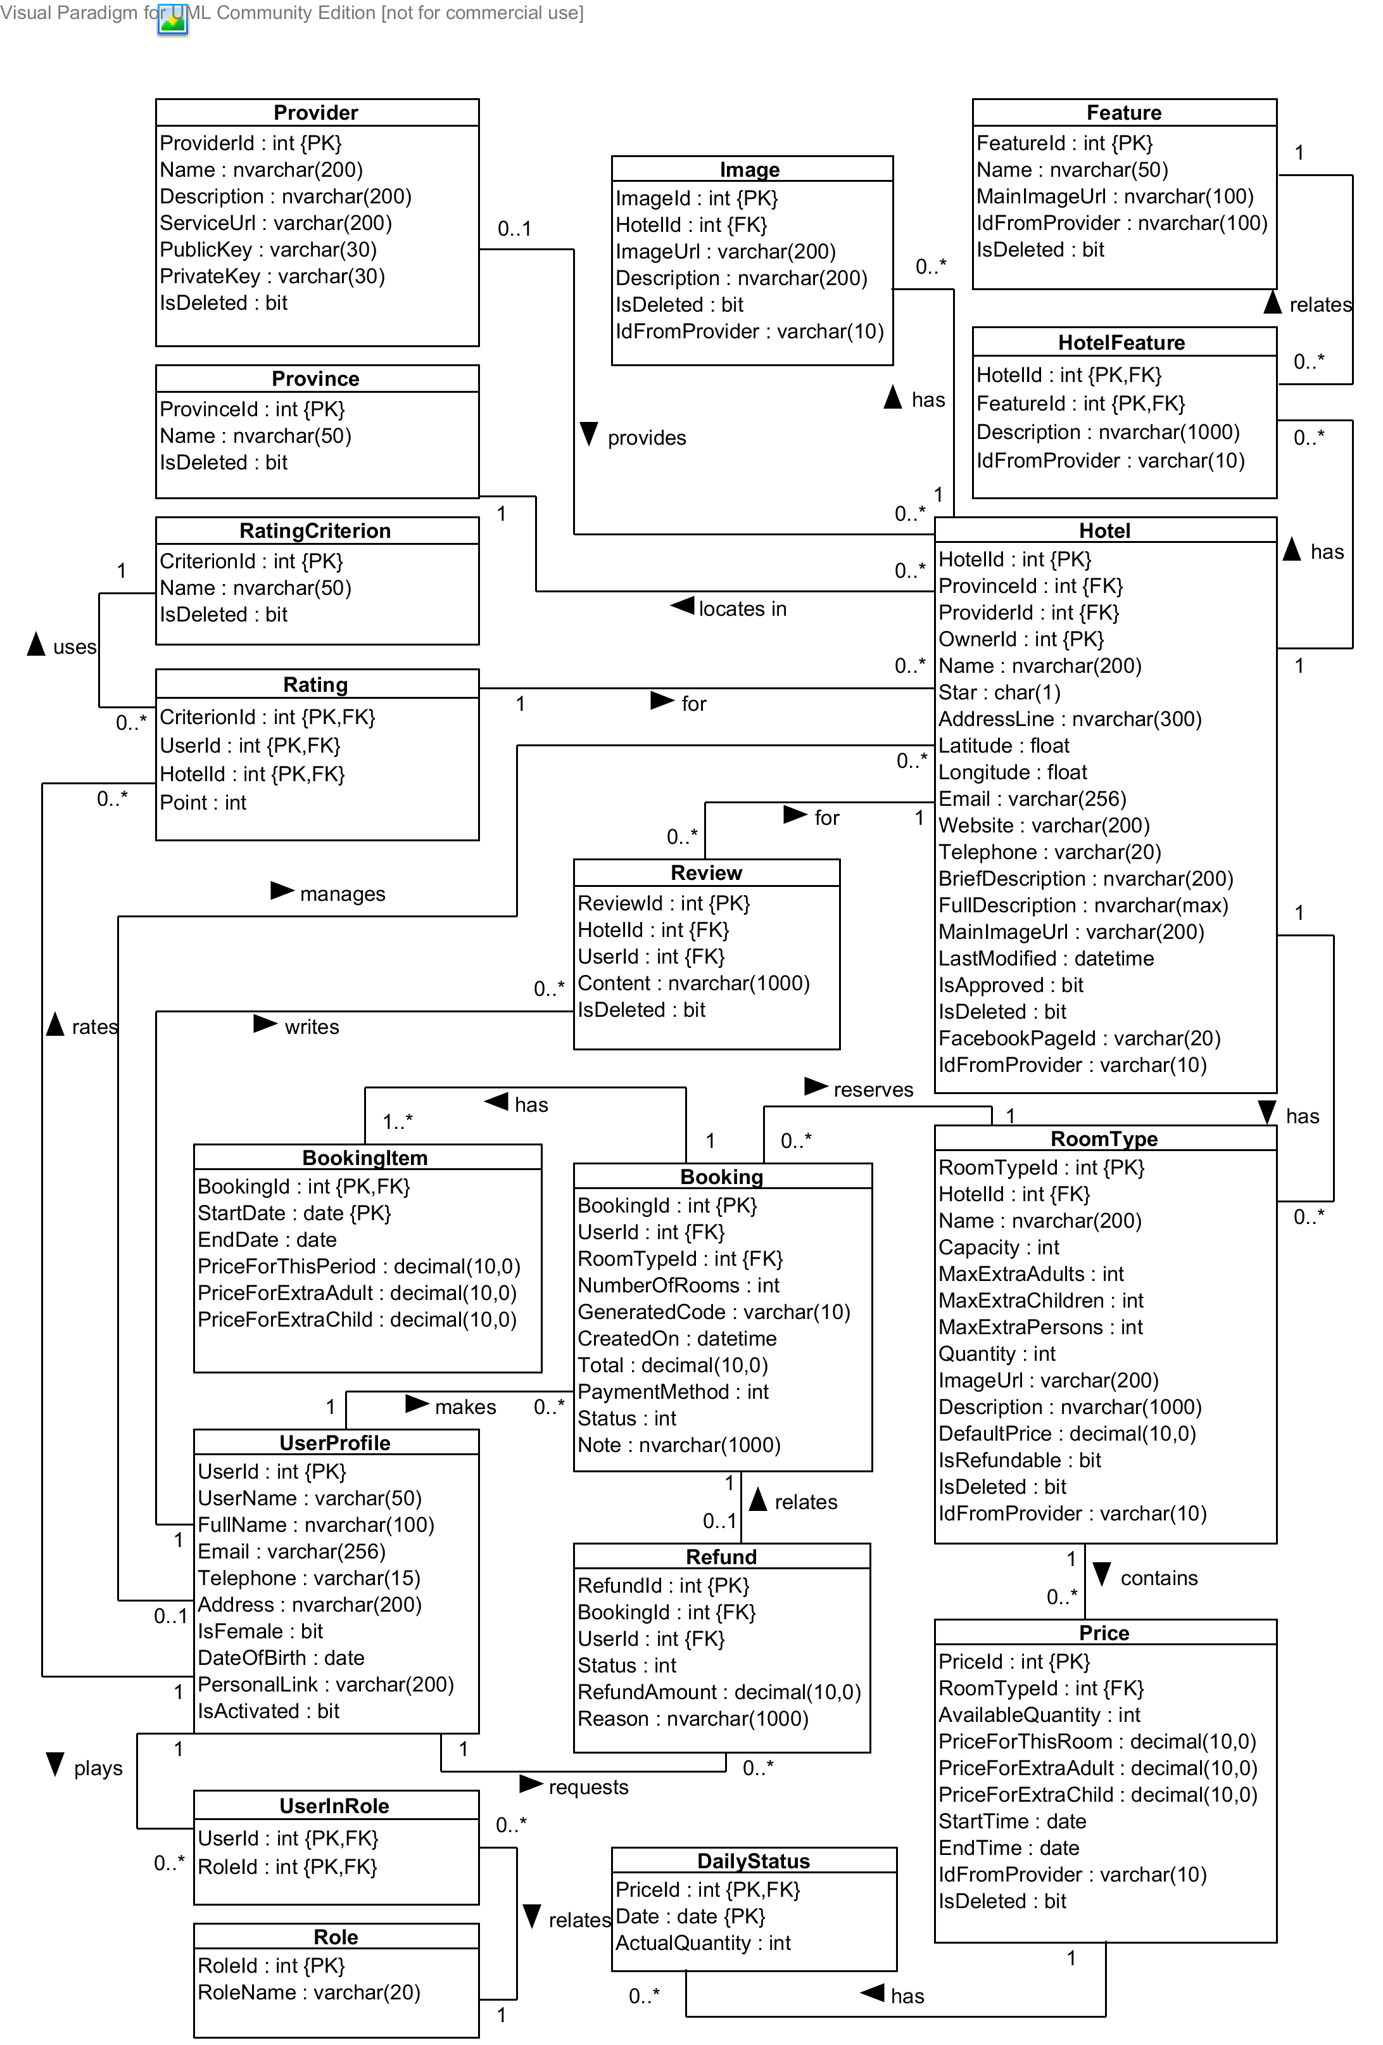

Diagram 20. Logical database design

#### Booking Relation

|  |  |  |  |  |  |  |
| --- | --- | --- | --- | --- | --- | --- |
| Field Name | Type | Nullable | Unique | Key | Default | Description |
| *BookingId* | int |  | 🗹 | PK |  | Unique id that differentiates a hotel from the others |
| *UserId* | int |  |  | FK |  | Id of the user who makes the booking |
| *RoomTypeId* | int |  |  | FK |  | Id of the room type booked by the user |
| *RoomQuantity* | int |  |  |  |  | Number of rooms the user booked for this room type |
| *ExtraAdults* | int |  |  |  |  | Number of extra adults, if any |
| *ExtraChildren* | int |  |  |  |  | Number of extra children, if any |
| *GeneratedCode* | varchar(10) |  | 🗹 |  |  | String that whill be used to verify with the hotel when the user checks in |
| *CreatedOn* | datetime |  |  |  |  | Time when the booking is created |
| *Total* | decimal(10, 0) |  |  |  |  | Total amount of the booking order |
| *PaymentMethod* | int |  |  |  | 1 | Method which the user uses to pay for the booking |
| *Status* | int |  |  |  | 1 | Status of the booking |
| *Note* | nvarchar(1000) | 🗹 |  |  |  | Additional note the user specifies for the hotel |

#### BookingItem Relation

|  |  |  |  |  |  |  |
| --- | --- | --- | --- | --- | --- | --- |
| Field Name | Type | Nullable | Unique | Key | Default | Description |
| *BookingId* | int |  |  | PK, FK |  | The id of the booking which this booking item belongs to |
| *StartDate* | date |  |  | PK |  | Date on which a booking item starts |
| *EndDate* | int |  |  |  |  | Date on which a booking item ends |
| *PriceForThisPeriod* | decimal |  |  |  |  | Price for the room in the period specified |
| *PriceForExtraAdult* | decimal |  |  |  |  | Price for an extra adult in the period specified, if any |
| *PriceForExtraChild* | decimal |  |  |  |  | Price for an extra child in the period specified, if any |

#### DailyStatus Relation

|  |  |  |  |  |  |  |
| --- | --- | --- | --- | --- | --- | --- |
| Field Name | Type | Nullable | Unique | Key | Default | Description |
| *PriceId* | int |  | 🗹 | PK, FK |  | Id of the price that this daily status belongs to |
| *Date* | date |  |  | PK |  | Date on which this daily status takes place |
| *ActualQuantity* | int |  |  |  |  | Actual available number of rooms on the day when the daily status takes place |

#### Feature Relation

|  |  |  |  |  |  |  |
| --- | --- | --- | --- | --- | --- | --- |
| Field Name | Type | Nullable | Unique | Key | Default | Description |
| *FeatureId* | int |  | 🗹 | PK |  | Unique id that differentiates a feature from the others |
| *Name* | nvarchar(50) |  |  |  |  | Name of the hotel feature |
| *MainImageUrl* | nvarchar(100) | 🗹 |  |  |  | Image url of the hotel feature |
| *IdFromProvider* | nvarchar(50) | 🗹 |  |  |  | Short description of the hotel feature |
| *IsDeleted* | bit |  |  |  | 0 | Whether the hotel feature is deleted or not |

#### Hotel Relation

|  |  |  |  |  |  |  |
| --- | --- | --- | --- | --- | --- | --- |
| Field Name | Type | Nullable | Unique | Key | Default | Description |
| *HotelId* | int |  | 🗹 | PK |  | Unique id that differentiates a hotel from the others |
| *ProvinceId* | int |  |  | FK |  | Id of the province where the hotel locates in |
| *ProviderId* | int | 🗹 |  | FK |  | Id of the provider who provides this hotel |
| *OwnerId* | int | 🗹 |  |  |  | Id of the owner who manages this hotel |
| *Name* | nvarchar(200) |  |  |  |  | Official name of the hotel |
| *Star* | char(1) |  |  |  |  | International quality of the hotel |
| *AddressLine* | nvarchar(300) |  |  |  |  | Address line of the hotel |
| *Telephone* | varchar(15) |  |  |  |  | Main telephone number of the hotel |
| *Email* | varchar(254) |  |  |  |  | Main email address of the hotel |
| *Latitude* | float | 🗹 |  |  |  | Latitude of the hotel’s address line |
| *Longitude* | float | 🗹 |  |  |  | Longitude of the hotel’s address line |
| *Website* | varchar(200) |  |  |  |  | Website address of the hotel |
| *BriefDescription* | nvarchar(500) |  |  |  |  | Short introduction about the hotel |
| *FullDescription* | nvarchar(max) | 🗹 |  |  |  | Full description of the hotel |
| *MainImageUrl* | varchar(200) | 🗹 |  |  |  | Url of the main image for the hotel |
| *LastModified* | datetime |  |  |  |  | Last time when the hotel’s information was modified |
| *IsApproved* | bit |  |  |  |  | Whether the hotel is approved or not |
| *FacebookId* | varchar(20) |  | 🗹 |  |  | Id of the Facebook page that has the hotel installed as a tab |
| *IdFromProvider* | varchar(10) | 🗹 |  |  |  | Id of the hotel if it is provided by a hotel data provider |
| *IsDeleted* | bit |  |  |  | 0 | Whether the hotel is marked deleted or not |

#### HotelFeature Relation

|  |  |  |  |  |  |  |
| --- | --- | --- | --- | --- | --- | --- |
| Field Name | Type | Nullable | Unique | Key | Default | Description |
| *HotelId* | int |  |  | PK |  | Id of the hotel that has the feature |
| *FeatureId* | int |  |  | FK |  | Id of the feature |
| *Description* | nvarchar(1000) | 🗹 |  |  |  | Custom description of hotel feature |
| *IdFromProvider* | varchar(50) | 🗹 |  |  |  | Id provided by hotel provider |

#### Image Relation

|  |  |  |  |  |  |  |
| --- | --- | --- | --- | --- | --- | --- |
| Field Name | Type | Nullable | Unique | Key | Default | Description |
| *ImageId* | int |  | 🗹 | PK |  | Unique id that differentiates an image from the others |
| *HotelId* | int |  |  | FK |  | Id of the hotel which the image belongs to |
| *ImageUrl* | varchar(200) |  |  |  |  | Url of the image |
| *Description* | nvarchar(200) | 🗹 |  |  |  | Description of what the image is about |
| *IdFromProvider* | varchar(10) | 🗹 |  |  |  | Id of the image if it is provided by a hotel data provider |
| *IsDeleted* | bit |  |  |  | 0 | Unique id that differentiates an image from the others |

#### Price Relation

|  |  |  |  |  |  |  |
| --- | --- | --- | --- | --- | --- | --- |
| Field Name | Type | Nullable | Unique | Key | Default | Description |
| *PriceId* | int |  | 🗹 | PK |  | Unique id that differentiates a price from the others |
| *RoomTypeId* | int |  |  | FK |  | Id of the room type that this price belongs to |
| *AvailableQuantity* | int |  |  |  | 1 | Number of available rooms for this room type in the period specified |
| *PriceForThisRoom* | decimal(10, 0) |  |  |  | 0 | Price for this room in the period specified |
| *PriceForExtraChild* | decimal(10, 0) |  |  |  | 0 | Price for an extra adult, if any |
| *PriceForExtraAdult* | decimal(10, 0) |  |  |  | 0 | Price for an extra child, if any |
| *StartTime* | date |  |  |  |  | Date on which the price becomes active |
| *EndTime* | date |  |  |  |  | Date on which the price becomes inactive |
| *IdFromProvider* | varchar(10) | 🗹 |  |  |  | Id of the price if it is provided by a hotel provider |
| *IsDeleted* | bit |  |  |  | 0 | Whethere the price is deleted or not |

#### Provider Relation

|  |  |  |  |  |  |  |
| --- | --- | --- | --- | --- | --- | --- |
| Field Name | Type | Nullable | Unique | Key | Default | Description |
| *ProviderId* | int |  | 🗹 | PK |  | Unique id that differentiates a provider from the others |
| *Name* | nvarchar(200) |  |  |  |  | Official name of the hotel data provider |
| *Description* | nvarchar(200) | 🗹 |  |  |  | Description of the services of the provider |
| *ServiceUrl* | varchar(200) |  |  |  |  | Base url of the services provided by the hotel provider |
| *PublicKey* | varchar(30) | 🗹 |  |  |  | Public key used to identify hotel consumer when information exchanges occur |
| *PrivateKey* | varchar(30) | 🗹 |  |  |  | Private key that only the hotel provider and its consumer know and keep it a secret |
| *IsDeleted* | bit |  |  |  | 0 | Where the hotel provider is deleted or not |

#### Province Relation

|  |  |  |  |  |  |  |
| --- | --- | --- | --- | --- | --- | --- |
| Field Name | Type | Nullable | Unique | Key | Default | Description |
| *ProvinceId* | int |  | 🗹 | PK |  | Unique id that differentiates a province from the others |
| *Name* | nvarchar(50) |  |  |  |  | Name of the province in 64 provinces in Vietnam |
| *IsDeleted* | bit |  |  |  |  | Where the hotel province is deleted or not |

#### Rating Relation

|  |  |  |  |  |  |  |
| --- | --- | --- | --- | --- | --- | --- |
| Field Name | Type | Nullable | Unique | Key | Default | Description |
| *CriterionId* | int |  |  | PK, FK |  | Id of the criterion being rated by the user |
| *UserId* | int |  |  | PK, FK |  | Id of the user who rates the hotel |
| *HotelId* | int |  |  | PK, FK |  | Id of the hotel being rated by the user |
| *Point* | int |  |  |  |  | Point that the user gives the hotel for the selected criterion |

#### RatingCriterion Relation

|  |  |  |  |  |  |  |
| --- | --- | --- | --- | --- | --- | --- |
| Field Name | Type | Nullable | Unique | Key | Default | Description |
| *CriterionId* | int |  | 🗹 | PK |  | Unique id that differentiates a criterion from the others |
| *Name* | nvarchar(50) |  |  |  |  | Name of the criterion used to rate the hotels |
| *IsDeleted* | bit |  |  |  | 0 | Whether the criterion is deleted or not |

#### Refund Relation

|  |  |  |  |  |  |  |
| --- | --- | --- | --- | --- | --- | --- |
| Field Name | Type | Nullable | Unique | Key | Default | Description |
| *RefundId* | int |  |  | PK |  | Unique id that differentiates a refund from the others |
| *BookingId* | int |  |  |  |  | Id of the booking which the refunds relates |
| *Status* | int |  |  |  |  | Status of the refund request |
| *RefundedAmount* | decimal(10, 0) | 🗹 |  |  |  | Amount that will be refunded to the user |
| *Reason* | nvarchar(1000) | 🗹 |  |  |  | Reason why the user wants the hotel to refund the bookings |
| *UserId* | int |  |  |  |  | Id of the user who requests the refund |

#### Review Relation

|  |  |  |  |  |  |  |
| --- | --- | --- | --- | --- | --- | --- |
| Field Name | Type | Nullable | Unique | Key | Default | Description |
| *ReviewId* | int |  | 🗹 | PK |  | Unique id that differentiates a review from the others |
| *HotelId* | int |  |  | FK |  | Id of the hotel that the review is about |
| *UserId* | int |  |  | FK |  | Id of the user who writes the review |
| *Content* | nvarchar(1000) |  |  |  |  | Content of the review written by the user |
| *IsDeleted* | bit |  |  |  | 0 | Whether the review is deleted or not |

#### RoomType Relation

|  |  |  |  |  |  |  |
| --- | --- | --- | --- | --- | --- | --- |
| Field Name | Type | Nullable | Unique | Key | Default | Description |
| *RoomTypeId* | int |  | 🗹 | PK |  | Unique id that differentiates a room type from the others |
| *HotelId* | int |  |  | FK |  | Id of the hotel which the room type belongs to |
| *Name* | nvarchar(200) |  |  |  |  | Official name of the room type specified by the hotel owner |
| *Capacity* | int |  |  |  |  | Default value of the number of persons who can stay in the room |
| *MaxExtraAdults* | int |  |  |  | 0 | Number of maximum extra children, if any |
| *MaxExtraChildren* | int |  |  |  | 0 | Number of maximum extra adults, if any |
| *MaxExtraPersons* | int |  |  |  | 0 | Number of maximum extra person, if any |
| *Quantity* | int |  |  |  | 1 | Number of physical rooms of this type in the hotel |
| *Description* | nvarchar(1000) | 🗹 |  |  |  | Main url of the image for the room type |
| *ImageUrl* | varchar(200) | 🗹 |  |  |  | Description of the room type |
| *DefaultPrice* | decimal(10, 0) | 🗹 |  |  |  | Default price for the room type |
| *IdFromProvider* | varchar(10) | 🗹 |  |  |  | Id of the room type if it is provided by a hotel provider |
| *IsRefundable* | bit |  |  |  |  | Whether bookings made for this room type can be refunded or not |
| *IsDeleted* | bit |  |  |  | 0 | Whethere the room type is deleted or not |

#### UserProfile Relation

|  |  |  |  |  |  |  |
| --- | --- | --- | --- | --- | --- | --- |
| Field Name | Type | Nullable | Unique | Key | Default | Description |
| *UserId* | int |  | 🗹 | PK |  | Unique id that differentiates a user from the others |
| *UserName* | varchar(50) |  |  |  |  | Unique name that will be use to log in the system |
| *FullName* | nvarchar(100) |  |  |  |  | Full name of the user |
| *Email* | nvarchar(256) |  |  |  |  | Email address of the user |
| *Telephone* | varchar(15) |  |  |  |  | Telephone number of the user |
| *Address* | nvarchar(200) |  |  |  |  | Address line of the user |
| *IsFemale* | bit | 🗹 |  |  |  | Whether the user is female or male |
| *DateOfBirth* | date |  |  |  |  | Date of birth of the user |
| *PersonalLink* | varchar(200) | 🗹 |  |  |  | Personal website of the user |
| *IsActivated* | bit |  |  |  | 1 | Whether the user is activated on the MHB system or not |

#### Role Relation

|  |  |  |  |  |  |  |
| --- | --- | --- | --- | --- | --- | --- |
| Field Name | Type | Nullable | Unique | Key | Default | Description |
| *RoleId* | int |  | 🗹 | PK |  | Unique id that differentiates a role from the others |
| *RoleName* | nvarchar(20) |  |  | PK |  | Name of the role |

#### UserRole Relation

|  |  |  |  |  |  |  |
| --- | --- | --- | --- | --- | --- | --- |
| Field Name | Type | Nullable | Unique | Key | Default | Description |
| *UserId* | int |  |  | PK, FK |  | Id of the role |
| *RoleId* | int |  |  | PK, FK |  | Id of the user in that role |

### Physical database design

Please note that in the physical database implemented using SQL Server 2008 R2, the tables wrapped in the dashed line, (namely *webpages_Roles*, *webpages_UserInRoles*, *webpage_OAuthMembership*, and *webpage_Membership*) are generated and supported by the MVC .NET 4.0 framework to help simplify the authentication and authorization processes.



Diagram 21. Physical database design